Metropolitan Transportation Authority
New York City Transit

AC Train Conducted EMI Test Procedure

Revision 2.0

April 17, 2001

MTA New York City Transit
130 Livingston Street

Brooklyn, NY 11201

Prepared by

T U R N E R
E N G I N E E R I N G
C O M P A N Y

Revision History

Date Revision Change

November 30, 1995 0.1 Draft from CETP 4.2 and FTR

December 15, 1995 1.0 Initial release

January 31, 1996 1.1 Section 2.2.1: Add Brakes in Emergency to modes under test. Instruct carbuilder to distinguish test artifact events from train events. Section 4.1, CET 6.4: Add clarification about excluded events. Whole document: Replace all track circuit 7 data with track circuit 5 data. Replace references to track circuit 7 in section 4.1 CET9, 6.2, 6.5.3, Figure 6-3. Provide updated frequency-dependent model calculations for track circuits 2, 5, and 18 in section 6.5 and Figure 6-3, to reflect worst-case circuit values. Provide updated Figures 6-6, 6-7, 6-13, 6-14, 6-15, 6-16, 6-18, and 6-19. Note that no measurement data is available for track circuit 5.

August 21, 1996 1.2 In Figure 6-3, use published I-cfc and I-ofc data from UMTA "Laboratory and Field Testing of NYCTA Power Frequency Track Circuits" report in place of similar field test data for I-obc and I-ofc, and update calculations of I-3io and I-3iu to use appropriate values.

April 17, 2001 2.0 Change all references from NTT to AC Train. Incorporate improvements from R142/R142A AC Train procurement. Add description of Dyre Avenue Test Track. Section 1.4: Delete R-110 references. Section 2.2.1: Expand description of tested modes. Section 2.2.3: Expand descriptions of worst-case track circuit responses. Provide new section 2.2.4 describing detailed Impulse and Repeating Broadband characteristics. Provide new section 2.2.5 with event categories. Section 3: Provide expanded test run examples and new chart. Section 4.1: Clarify steps and MTR/ICR setup sequence. Provide clarified block diagrams and track circuit connection details. Provide record and playback level details. Clarify test steps for playback evaluation. Provide more detail on Unoccupied case testing. Section 4.2: Clarify audio frequency filter / detector setup. Move ETA details to new Appendix B. Section 6: Add Dyre Avenue test track description and data. Section 6.2: Provide data on 1,005 ft 25 Hz track circuit.

Table of Contents

List of Figures iv
1 Introduction 1
1.1 AC Train Conducted EMI Test Procedure 1
1.2 AC Train Procurements 1
1.3 Objectives of the AC Train Conducted EMI Test Procedure and the Conducted EMI Test 2
1.4 Reference Information 3
1.5 Contents of This Procedure 3
2 Conducted EMI Test Requirements 4
2.1 General Requirement 4
2.2 Worst-Case Tests 4
2.2.1 Worst-Case Train Emission Conditions 4
2.2.2 Worst-Case Train Test Runs 6
2.2.3 Worst-Case Track Circuits 7
2.2.4 Conducted Emission Characteristics 7
2.2.5 Conducted Emission Events 11
3 Requirements for the Carbuilder Conducted EMI Test Procedure Submittal 14
4 Recommended Conducted EMI Test Method and Test Equipment Configuration 20
4.1 Recommended Conducted EMI Test Procedure 20
4.2 Field Test Equipment Arrangement 37
4.2.1 EMI Test Adapter 37
4.2.2 Kepco Bipolar Power Amplifier 38
4.2.3 Krohn-Hite Tunable Filter 38
4.2.4 Digital Audio Tape (DAT) Recorder 39
4.2.5 Multi-Channel Chart Recorder 40
4.2.6 Oscilloscope 41
4.2.7 Fast Fourier Transform (FFT) Signal Analyzer 41
4.2.8 Audio Frequency Filter / Detector 41
4.2.9 NYCT Signals Track Coupling Network and Relays 42
4.2.10 Current Transducers 43
4.3 EMI Test Adapter 43
4.3.1 Functions 43
4.3.2 ETA Inputs and Outputs 44
4.3.3 ETA Controls and Test Points 45
5 Requirements for the Carbuilder Conducted EMI Test Report Submittal 48
6 Conducted EMI Test Reference Information 50
6.1 Test Track Locations 50
6.1.1 Sea Beach Test Track 50
6.1.2 Dyre Avenue Test Track 53
6.2 AC Train Worst-Case Track Circuits 56
6.2.1 CETP Track Circuits 61
6.2.2 Track Circuit 3 62
6.2.3 Track Circuit 5 66
6.2.4 Track Circuit 2 69
6.2.5 Track Circuit 18 72
6.3 Acronyms 75

Appendix A Computation of I-rcv / I-3, I-rcv / I-train

Appendix B ETA Block Diagram and Schematic

List of Figures

Figure 2-1 Impulse Characteristics on Margin Test Relay
Figure 2-2 Repeating Broadband Characteristics on Margin Test Relay

Figure 3-1 Example Test Runs
Figure 3-2 Example Test Run Log

Figure 4-1 NYCT AC Train Conducted EMI Test Configuration - Recording Mode
Figure 4-2 EMI Test Adapter (ETA) Block Diagram
Figure 4-3 Conducted EMI Test Equipment List
Figure 4-4 NYCT CETP Record and Playback Levels
Figure 4-5 Conducted EMI Stripchart Data Example
Figure 4-6 FFT Plot Example
Figure 4-7 NYCT AC Train Conducted EMI Test Configuration - Playback Mode
Figure 4-8 Typical Strip Chart Channel Assignment

Figure 6-1 Sea Beach Test Track General Arrangement
Figure 6-2 16th Avenue Substation Connection Diagram
Figure 6-3 Dyre Avenue Test Track General Arrangement
Figure 6-4 Baychester Substation Connection Diagram
Figure 6-5 Conducted EMI Worst Case Track Circuit Data
Figure 6-6 NYCT Track Circuit Parameters
Figure 6-7 Track Circuit 3 General Connection Diagram
Figure 6-8 Track Circuit 3 Connection Diagram
Figure 6-9 Track Circuit 3 Calculated H-cond Magnitude and Phase Plot
Figure 6-10 Track Circuit 3 Sea Beach Actual Measured H-cond Plot
Figure 6-11 Track Circuit 5 General Connection Diagram
Figure 6-12 Track Circuit 5 Connection Diagram
Figure 6-13 Track Circuit 5 Calculated H-cond Magnitude Plot
Figure 6-14 Track Circuit 5 Calculated H-cond Phase Plot
Figure 6-15 Track Circuit 2 General Connection Diagram
Figure 6-16 Track Circuit 2 Calculated H-cond Magnitude and Phase Data
Figure 6-17 Track Circuit 2 Sea Beach Actual Measured H-cond Plot
Figure 6-18 Track Circuit 18 General Connection Diagram
Figure 6-19 Track Circuit 18 Calculated H-cond Magnitude and Phase Plot
Figure 6-20 Track Circuit 18 Sea Beach Actual Measured H-cond Plot

Metropolitan Transportation Authority New York City Transit
AC Train Conducted EMI Test Procedure

Introduction

AC Train Conducted EMI Test Procedure

This AC Train Conducted EMI Test Procedure (CETP) is an element of the New York City Transit (NYCT) AC Train Electromagnetic Compatibility (EMC) Program. The CETP provides the AC Train carbuilder with NYCT's requirements for a train-level, on-site conducted electromagnetic interference (EMI) qualification test procedure and qualification test. This CETP provides a recommended test method, test arrangement, and related technical information for performing a required Conducted EMI test. The CETP also provides requirements for submittal of the test procedure and test results documentation.

Generally, the CETP requires the carbuilder to perform a Conducted EMI test in worst-case track circuits set up by NYCT. In the test, the carbuilder demonstrates that the train's worst-case emissions do not disturb the worst-case track circuits, with the required margin. The carbuilder must perform the test to the satisfaction of NYCT.

To accomplish this, the carbuilder operates the AC Train to produce worst-case emissions in a worst-case track circuit provided by NYCT on a NYCT test track. A test instrument setup supplied by the carbuilder monitors and records the current in the track relay, called the In-Circuit Relay. The test setup plays back and amplifies the monitored In-Circuit Relay voltage by a specified gain, and drives the amplified voltage into a separate track relay, called the Margin Test Relay. If the amplified voltage does not disturb the normal operation of the Margin Test Relay, the AC Train passes the test.

NYCT worst-case track circuits are installed near and accessible from the 16th Avenue Substation on the B Division Sea Beach N Line, track E4, in Brooklyn, and the Baychester Substation on the A Division Dyre Avenue Line, track Y3, in The Bronx.

AC Train Procurements

NYCT is procuring new trains with AC propulsion systems (AC Trains). The AC Train program objective is to place trains in passenger service with superior performance and passenger comfort, improved reliability, and reduced maintenance and operating costs. Component AC Train technologies include AC propulsion, AC auxiliaries, trainline monitors, and new communications and data management functions.

As part of the AC Train program, NYCT has established standards and procedures to ensure EMC. EMC is the desired condition where the signal system, trains, and other electronic equipment operate without adverse or unintended effects, despite their proximity and interconnected circuit and signal paths. At the NYCT, EMC refers to well-established modes of conducted, inductive, and radiated coupling between train equipment, the existing signal system, and other nearby equipment.

The purposes of the AC Train EMC program are to ensure that the AC Trains are safely and reliably compatible with present NYCT equipment, operations, and procedures. In the AC Train program, EMC issues include:

- AC Trains and their ac propulsion and other high power vehicle subsystems must be compatible with NYCT's existing 25 and 60 Hz track circuits, other signal system equipment and components, existing fleets of trains with switched resistor DC propulsion, existing traction power system of substations and third rail, as well as other electronic systems such as communications-based train control (CBTC) and voice and data communications systems including portable radios.

- Electromagnetic interference (EMI) potentially consists of radiated, conducted, and inductively coupled energy.

- AC Trains must not be susceptible to interference, including from portable radio transmitters.

In addition, AC Trains must have controlled EMI characteristics to avoid adverse impact on future signal and communication systems.

Objectives of the AC Train Conducted EMI Test Procedure and the Conducted EMI Test

The objective of the CETP is to provide the AC Train carbuilder with NYCT's requirements for a train-level, on-site conducted EMI qualification test procedure and for performance and documentation of a qualification test per the procedure.

The objective of the carbuilder's Conducted EMI Test is to demonstrate that the worst-case AC Train emissions conducted into worst-case NYCT signal system track circuits meet NYCT's requirements for safe and reliable operation. In particular, the worst-case emissions, when amplified to the specified level, must not disturb the normal operation of any of the worst-case track circuits, either when the track circuit is occupied or unoccupied.

This CETP is not applicable to DC trains, which have an extensive field-proven history of electromagnetic compatibility with the NYCT signal system. Comparisons of performance of DC trains and AC Trains are not relevant to EMC qualification of AC Trains.

Reference Information

The following are reference information for NYCT AC Train EMC Program and this CETP.

EMCS EMC Standards for Procurement of AC Trains, MTA NYCT, April 2001

TG-88 NYCTA NTTT EMC Project CM-828, Conductive EMI Analysis, Track Circuit Parameters, Turner Gold France Engineering Corporation, November 19, 1992

UMTA-MA-06-0153-85-12 Laboratory and Field Testing of NYCTA Power Frequency Track Circuits, West and Holmstrom, February 1986

UMTA-MA-06-0153-85-5 Conductive Interference in Rapid Transit Signaling Systems - Volume I: Theory and Data, Holmstrom, November 1985

UMTA-MA-06-0153-85-6 Conductive Interference in Rapid Transit Signaling Systems - Volume II: Suggested Test Procedures, May 1987

Contents of This Procedure

Section 2 of this Procedure describes general requirements concerning the Conducted EMI Test which the carbuilder must fulfill. Section 3 describes the requirements for the Carbuilder Conducted EMI Test Procedure submittal.

Section 4 provides NYCT's recommended Test Procedure Method for performance of the test, recommended test setup, and brief descriptions of the recommended test equipment. Section 5 describes requirements for the Carbuilder Conducted EMI Test Report submittal.

Section 6 provides reference information concerning the Conducted EMI Test, including for the test track, the test equipment, and the NYCT worst-case track circuits.

Appendix A provides a method and data for computing the current which will be coupled into a worst-case track circuit for a selected train configuration. Appendix B provides the schematic diagram for the EMI Test Adapter.

Conducted EMI Test Requirements

General Requirement

The carbuilder shall demonstrate that the train's worst-case conducted emissions are electromagnetically compatible with NYCT signal system, by performance and documentation of a Conducted EMI test compatible with this CETP.

This consists of three steps:

1] Submit a Carbuilder CETP: The carbuilder shall develop and submit a Carbuilder Conductive EMI Test Procedure (Carbuilder CETP) compliant with the requirements of section 3 of this CETP.

2] Perform the Test: The carbuilder shall perform a test compliant with the Carbuilder CETP and section 4 of this CETP. In the test, the carbuilder shall demonstrate that the train's worst-case emissions do not disturb the worst-case track circuits, with the required margin.

3] Submit a Carbuilder Test Report: The carbuilder shall document the test and submit a test report compliant with the Carbuilder CETP and section 5 of this CETP.

Worst-Case Tests

Worst-Case Train Emission Conditions

The carbuilder shall perform tests to determine the modes and conditions under which the train makes its worst-case emissions, considering propulsion, braking, and auxiliaries. Typically, the worst-case occurs when the train is operating at maximum power or in a mode or submode transition; such as when regeneration is stopped or when the line contactor opens. Auxiliary electric equipment can make a substantial contribution to worst-case emissions. Previous tests have shown that spin-slide during maximum regenerative brake may be a worst-case condition.

The carbuilder shall perform sufficient test runs to identify worst-case conditions for normal, abnormal, and failed operating conditions; and in the full range and combinations of applicable operating modes, speeds, train lengths, loading, and failure conditions.

Modes: The carbuilder shall test modes including appropriate combinations of maximum and minimum acceleration; dynamic braking; regenerative braking; alternation between regenerative and dynamic braking when line receptivity changes, especially when line contactors open or close; spin-slide, especially in regenerative braking; HVAC and other auxiliaries at maximum and minimum power; in forward and reverse directions; with cutout propulsion and dynamic braking cut-out in one or more cars and trucks.

The carbuilder should confirm that modes which are not expected to produce conducted emissions in fact do not produce emissions, such as brakes in emergency and non-regenerative dynamic braking after the transition impulses have completed.

The tests shall be performed at available line voltage with a dedicated traction power substation feeding the test track, with no feed to the test track from adjoining substations. The supply is typically at the high end of the normal range when the train is close to the substation. When a heavy train accelerates far from the substation, the third rail voltage can be low enough to cause low voltage dropout of the propulsion system. If low voltage dropout occurs, tests shall be arranged to minimize the impact of dropout on the test results of interest.

Speed: The carbuilder shall perform sets of test runs to identify worst-case conditions, arranged so the speed at which the train passes a test point in successive runs changes in increments of no more than 10 mph. As noted below in section 2.2.2, the usual test point is the feed end of the worst-case track circuit.

Length: The carbuilder shall test a train at the minimum and maximum length used in revenue service. NYCT does not normally operate two-car trains in revenue service, so NYCT may give special consideration to conducted emission characteristics of two-car trains, if they are a worst case.

Loading: The carbuilder shall test trains loaded at AW0 with all cars powered; trains loaded at AW3 with all cars powered; and trains in which a live unit pushes an equal length powered-down unit, to minimize the acceleration rate as the train passes through the sensitive track circuit area and sweeps through the track signaling frequencies.

Regeneration Receptivity Level: The carbuilder shall test a train regenerating into a fully receptive line, a partially receptive line, and a lightly receptive line.

Spin Slide: The carbuilder shall test a worst-case train with spin slide active, during acceleration and regenerative braking. During the test, the carbuilder shall wet or soap the track so that, at a minimum, the leading two power cars have a major slip during the test run. Previous tests have shown that the spin slide condition during maximum regenerative brake is a worst-case condition

Failure Conditions: The carbuilder shall test for each annunciated failure under which the train can continue running at reduced performance, such as the partial loss of the line filter capacitor bank. The carbuilder shall test relevant combinations of unannunciated failures related to EMI. Failure modes tested shall be consistent with the carbuilder’s EMI Safety Analysis.

As noted above, the carbuilder shall test the possible operating ranges, modes, and combinations to identify worst cases. From among those tests, the carbuilder shall select, further test, and document conditions for Propulsion, Braking, and Auxiliary worst-case emissions. The combination of tests shall be approved by NYCT.

Worst-Case Train Test Runs

Previous tests of AC Trains on NYCT worst-case track circuits showed train emissions with greatest effect on the track circuits when a train enters or modulates regenerative braking, especially due to spin-slide; when a train makes a submode change, especially in regenerative braking; when a line contactor interrupts regeneration; or when the train is using full power at medium speed near the transmit end of the track circuit.

Previous tests have used the following runs, among others:

Occupied Regen Test: Start with the train in the block near the receive end. Full acceleration from the receive end toward the feed end of the track circuit; transition into coast near the feed end; full service regenerative brake to zero speed

Unoccupied Regen Test: Start with the train outside the block, beyond the transmit end. Full acceleration toward the track circuit feed end; transition into coast near the feed end; enter the block; and full service regenerative brake to zero speed

Occupied Power-Coast: Start with the train in the block near the receive end. Full acceleration from the receive end toward the feed end of the track circuit to about 10 mph; two seconds of coast; two seconds more of full acceleration; repeating until the train reaches the feed end of the track circuit

Unoccupied Coast-Brake: Start with the train outside the block, beyond the transmit end. Full acceleration to maximum allowable speed approaching the feed end of the track circuit; transition into coast for two seconds near the feed end; enter the block; two seconds of full service regenerative brake; two seconds of coast; repeating until the train reaches zero speed.

The carbuilder shall investigate these and other runs to determine worst-case emission runs. For example, the test runs may be similar to those listed in Figure 3-1.

The carbuilder shall arrange test runs so that the usual test artifact events at block entry and turn-on of the regeneration load can be clearly distinguished from train events, such as mode transition and regeneration variation. The carbuilder shall note each test artifact on the test run printouts.

Worst-Case Track Circuits

The carbuilder shall test the train worst-case emissions for the Propulsion, Braking, and Auxiliary conditions against the Conducted EMI worst-case track circuits identified by NYCT. The carbuilder shall demonstrate that the worst-case train emissions in each condition, when amplified by the safety margin specified in the AC Train EMC Standards, do not cause incorrect operation of a NYCT track circuit.

In general, a worst-case track circuit is a long track circuit close to a substation, with the receiver end closer to the substation. Track circuits with low receive-end impedance and low track current operating levels tend to be most sensitive to train emissions. For single rail track circuits, the worst-case is when the signal rail is adjacent to the third rail. When a train is operating in a worst-case track circuit, its emissions cause the greatest impact when the train is far from the receiver.

NYCT has identified four track circuits as worst-case for AC Trains. These are described in detail in section 6.

Conducted Emission Characteristics

NYCT separated train emissions into three general categories: Impulse emissions, Repeating Broadband emissions, and Harmonic emissions. The categories describe idealized or simplified characteristics, rather than absolute criteria. A measured emission may have characteristics of one or more of these categories.

The carbuilder shall propose classification of the AC Train worst-case emissions into the three general categories. NYCT shall make the final determination on the classification of emissions into categories for the purpose of determining railcar compliance with NYCT EMC Standards. NYCT may give special consideration to pass/fail criteria applicable to particular conducted emission characteristics of an AC Train, based on the carbuilder’s assessment of the applicable category, cause, potential impact, worst case duration and worst-case repetition rate.

Impulse Emissions: An Impulse is an abrupt and brief change or set of changes in current which contains broadband energy, including energy at the operating frequency of NYCT track relays. An Impulse emission of sufficient amplitude can cause a track relay to wrongly change state, either by pickup or dropout, for a short time, such as for up to a half-second. At NYCT, Impulse emissions from previously tested AC Trains most frequently affect the NYCT signal equipment, compared to other types of emissions.

Dual element AC track circuit relays have response times of approximately 0.1 to 0.2 s, per UMTA-MA-06-0153-85-12, Laboratory and Field Testing of NYCTA Power Frequency Track Circuits, West and Holmstrom, February 1986. Switching on a full level track signal causes the relay to open its back and close its front contacts about 0.1 to 0.2 s later. Similar response times apply to switching off the track signal.

Accordingly, a single transient emission or a series of transient emissions causing relay contact events occurring in an interval no longer than 0.2 s, when isolated in time from similar events by 1.0 s or longer, is defined as an Impulse.

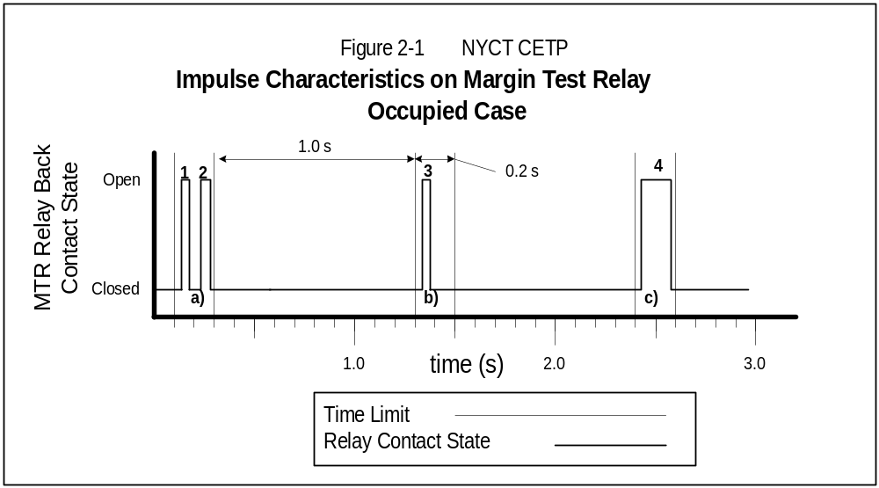In Figure 2-1 below, for an occupied case, events 1, 2, 3, and 4 are classified as Impulses. Events 1 and 2 occur within a period of less than 0.2 s, in interval a). Event 3 occurs more than 1.0 s after event 2. Event 4 occurs more than 1.0 s after event 3, and is less than 0.2 s in duration.

Impulse emissions are frequent events during normal operations at NYCT. Certain types of Impulse events are not relevant to or considered in evaluating train conducted emissions. These include Impulse emissions caused by shoe bounce due to track or third rail singularity, third rail gaps, or entry into or exit from a track circuit. During CET testing, switching on the regenerative test load at the substation causes a strong Impulse emission, which is a test characteristic, not a train characteristic, and is not considered in evaluating conducted emissions. Impulses caused by singular, extraordinary events such as emergency brake application or high speed circuit breaker trip are not considered in evaluating train conducted emissions.

AC Trains previously tested at NYCT make substantial Impulse emissions on transition from power to coast to brake and brake to coast to power. The AC Trains also make Impulses on mode changes into and out of regeneration, and during spin-slide. All these Impulse types are relevant to and are considered in evaluating AC Train conducted emissions.

Repeating Broadband Emissions: Repeating broadband emissions are defined as transient or sustained emissions which occur more frequently or for a longer period than permitted under the Impulse definition above. See Figure 2-2 below. Case 1 shows transients which occur for a period longer than permitted under the Impulse definition.

The separation between the impulses in Repeating Broadband emissions may be short or long. In long separation Repeating Broadband emissions, the time between impulses is longer than the relay response time, but shorter than the 1.0 s separation permitted for Impulse emissions. See Figure 2-2, Case 2, events 3) or 4) with events 1) and 2)

In short separation Repeating Broadband emissions, the time between impulses is shorter or about equal to the relay response time. The total time duration of the string of impulses is longer than the response time of the relay. See Figure 2-2, Case 3, group b).

If the causes of impulses are random or external events, such as changes in line receptivity during regenerative braking, the time intervals between them tend to be random. Response of the relay to such a string of impulses is a jerky random motion. The first impulse in a repeating string of impulses might bounce the relay vane up. The second impulse is as likely to bounce it down as to bounce it up further. On average, the relay vane will vibrate or rattle randomly, but will not lift and stay up. This effect on the relay is the same as the relay response to continuing broadband random noise.

If a sequence of such impulses of sufficient amplitude occurs at regular intervals that are nearly exact multiples of 1/60 s for a 60 Hz track circuit (or 1/25 s for a 25 Hz track circuit), a relay could be held in the wrong state for several seconds. These are periodic Repeating Broadband emissions. Periodic Repeating Broadband emissions are of great concern for potential adverse impact on signal system operation, whether the emissions are of long separation or short separation. See Figure 2-2, Case 3, event c).

In Figure 2-2 below, events in Case 1 group a) are classified as short separation Repeating Broadband emissions, since they span more than 0.2 s. In Case 2, events 3) or 4) are long separation Repeating Broadband emissions, because they begin less than 1.0 s after the events in group a). Events in Case 3 group b) are short separation Repeating Broadband emissions, because they are short separation impulses lasting more than 0.2 s.

The event in Case 3 or Case 4 group c) is a periodic Repeating Broadband emission or perhaps a Harmonic emission, because it spans more than 0.2 s, and because it begins less than 1.0 s after the last impulse in group b) ends. Spectral and time analysis of the relay voltage or current could provide further information to distinguish whether the emission was a Repeating Broadband or Harmonic emission.

Some AC Trains previously tested at NYCT had significant Repeating Broadband emissions, especially in mode transitions and during regenerative braking. In the past, AC Train carbuilders and propulsion suppliers have eliminated or significantly reduced Repeating Broadband emissions by careful control of mode transition effects.

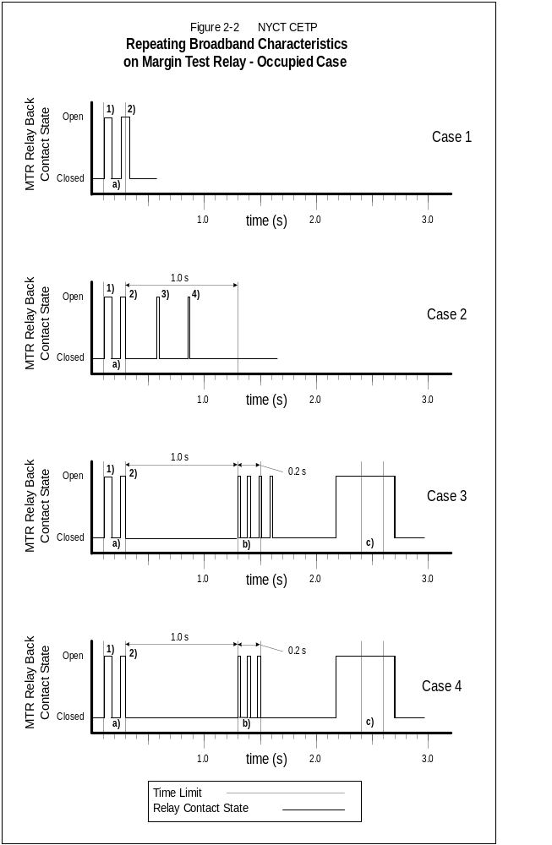

Harmonic Emissions: Harmonic emissions are sustained emissions at a fixed or sweeping frequency. These emissions carry energy at a fundamental frequency, with or without higher harmonics, with a sinusoidal or any other periodic waveform. To be considered Harmonic emissions, the impulses or transients giving rise to them must occur at nearly uniformly spaced points in time; and the time interval between impulses cannot change greatly in an interval of several relay response times. Harmonic emissions have power content concentrated into bands centered at frequencies that are harmonics of the basic pattern of impulses of the emissions.

To cause interference with the NYCT signaling system, an emission harmonic frequency has to be closer to the signaling frequency than a frequency interval given approximately by the inverse of the relay response time, or about 5 to 10 Hz for NYCT track circuits. Emission harmonics farther away from signaling frequencies than that will cause the relay vane to vibrate but not lift. Harmonic emissions occurring near the signaling frequency and of sufficient amplitude can cause a track relay to wrongly change state, either by pickup or dropout, for a sustained time as long as many seconds. Because Harmonic emissions have the greatest potential to nearly exactly mimic actual NYCT track signals, they are of special concern.

The typical sources of Harmonic emissions in rail vehicles are repetitive switching events in the propulsion or auxiliary inverters, in which the steadiness of the repetition frequency is a necessary operating characteristic of the equipment. For example, during regenerative braking with a partially receptive line, braking chopper modulation has produced Harmonic emissions.

AC Trains with suitable input filters previously tested at NYCT did not have significant Harmonic emissions compared to the levels required to disturb relay operation.

Conducted Emission Events

NYCT has identified typical railcar conducted emission events. Table 2-1 shows the events and their categories:

Table 2-1
Conducted Emission Event Categories
ID | Description | Category | Comment
Inverter and Other Equipment | Harmonic emissions from inverter, brake chopper, or other equipment such as static converter, LVPS, or auxiliary compressor. Emissions may be principal stator frequency (Fs), stator harmonic (e.g., 6 x Fs), modulation frequency such as for PWM Mode carrier, or cross modulation product of carrier and stator frequency. | Harmonic | Line filters reduce these emissions from inverters or equipment to a predictable level. CETP design guidelines provide reference information needed to relate train emission levels to track circuit interference levels.
Key On | Current impulse when train is keyed on as each line capacitor in train starts charging during initialization of train. | Impulse | Event is a one-time event, since it cannot be repeated until line capacitors discharge. Event can be excluded from further consideration if its duration is acceptable to NYCT.
Emergency Brake | Current impulse when emergency brake is activated, as each inverter is disconnected from line. | Impulse | Event is a one-time event, since it cannot be repeated until emergency brake trainline resets. Event can be excluded from further consideration if its duration is acceptable to NYCT.
Fault Shutdown | Current impulse when high speed circuit breaker trip or propulsion shutdown occurs. | Impulse | Event is a one-time event, since it cannot be repeated until fault is reset. Event can be excluded from further consideration if its duration is acceptable to NYCT.
Line Contactor Opening and Closing | Current impulse when changing operating conditions cause line contactor to open, such as undervoltage cutout in acceleration, overvoltage or loss of ripple detection in regeneration. Impulse caused by interruption of current.  Current impulse when line contactor closes to resume operation. Impulse caused by voltage difference between dc link voltage and third rail voltage. | Impulse, Set of Impulses, or Repeating broadband emissions | Event can be an Impulse or a set of Impulses or Repeating Broadband emissions, as the line contactor for each inverter can open or close with slightly different timing. Maximum duration of Impulse set is a concern. Minimum repetition interval and maximum number of repetitions of Impulse sets is a concern.
Spin-Slide Modulated Braking | Current impulses or harmonic energy when Spin-Slide modulates regeneration braking levels. | Set of Impulses or Repeating Broadband emissions | Extended spin-slide event during regen braking can generate a set of Impulses or Repeating Broadband emissions, as each inverter independently applies and releases electric regen braking. Maximum duration of Impulses or Harmonic energy is a concern. Minimum repetition interval and maximum number of repetitions of spin-slide events is a concern.
Mode Change | Current impulse when inverter changes mode, such as from PWM to Block modulation pattern; from high regen level to low regen level; from power to braking or braking to power; or from constant torque to constant power mode. | One or more Impulses per transition | Event set tends to be once per transition. Maximum duration of Impulse set is a concern. Minimum repetition interval and maximum number of repetitions of Impulse sets is a concern.
Third Rail Gap or Shoe Bounce | Current impulse when car’s last third rail shoe leaves third rail or when it bounces at third rail discontinuity. | Impulse | Event is not relevant to train conducted EMI performance, if the operation of the shoe suspension is otherwise acceptable. Rail gap or discontinuity event should be noted as such on stripcharts. Note, a rail gap or shoe bounce event should repeat at a fixed location, even when operating conditions change. To confirm that an event is an acceptable shoe bounce, an observer should be able to see or hear the arc at that spot.
Block Entry | Current impulse as train first occupies block or leaves block. | Impulse | Event is not relevant to train conducted EMI performance. Block entry event should be confirmed by audio track of DAT recording and noted on stripcharts.
Regen Load On | Current impulse when regen load is switched on. | Impulse | Event is not relevant to train conducted EMI performance. Regen Load On event should be confirmed by audio track of DAT recording and noted on stripcharts.
Regen Load Off | Current impulse when regen load is switched off. | Impulse | Event is not relevant to train conducted EMI performance. Regen Load Off event should be confirmed by audio track of DAT recording and noted on stripcharts.

Requirements for the Carbuilder Conducted EMI Test Procedure Submittal

The carbuilder shall develop a Carbuilder Conductive EMI Test Procedure (Carbuilder CETP) compliant with the following requirements, and submit it to NYCT for approval.

The Carbuilder CETP shall include the following sections or material.

Introduction: The Introduction section provides the purpose, scope, applicable requirements, participants, test procedure overview, and organization for the rest of the report.

Test Schedule: The Test Schedule section shows the test preparation, test performance, and test reporting activities in a bar or Gantt presentation, and describes the task milestones.

Train Configuration Under Test: The Train Configuration Under Test section specifies the general configuration of the train relevant to EMI, including train configurations and number of cars, propulsion units, and auxiliary units; current and voltage ratings for power units; line filter parameters and other EMI-related devices; and the values of any items or parameters which could affect EMI performance, such as propulsion unit and propulsion controller firmware revision numbers and EMI Detector action setpoints, if an EMI Detector is being provided.

Test Track: The Test Track section describes the test track and configuration planned for the test. This section notes any differences or modifications to the test track configuration described in section 6 of this report.

Test Equipment Configuration: The Test Equipment Configuration section describes the carbuilder's planned test equipment configuration, including the list of test equipment with model numbers, connection diagram, and the planned calibration method. Calibration includes both:

Instrument Calibration: Record of calibration of a measurement instrument to ensure it provides the correct readings for a known input, typically provided by a cal lab or comparison to a known source.

Setup Calibration: Calibration of the combined instrument setup to demonstrate that the end-to-end scaling and response of the system is correct, from transducer to analyzer to recorder to playback to printout.

Test Runs: The Test Runs section provides a list of train runs the carbuilder plans to identify the Propulsion, Braking, and Auxiliary worst-case conditions. For each run, the Test Run List provides an identifier and states the train configuration, including length, loading, and failure condition; operating mode, direction, and speed; and notes as required on the run purpose or condition. For example, the Test Runs List may be similar to the examples in Table 3-1 and Figure 3-1.

Test Steps: The Test Steps section lists the test steps the carbuilder plans to perform the tests. This section notes any differences or modifications to the test steps described in section 4 of this report.

Test Data Collection: The Test Data Collection section describes the test data to be collected and gives examples of the data format to be used and how it is to be recorded, indexed, and organized. For example, the Test Log may be similar to Figure 3-2.

Test Report Format: The Test Report Format section provides an outline for the Carbuilder Conducted EMI Test Report. The Test Report shall consist of sections including Introduction, Test Result Conclusions, Train Configuration Under Test, Test Track, Test Equipment Configuration, Test Procedure, Test Runs and Results, and Test Data.

Table 3-1
NYCT Conducted EMI Example Test Run Type List
Sea Beach Test Track
No. | Test Type | Run Description | Notes
1 | North  Min Power Accel + FSB Dyn Brake | Start at 18th Ave, with north (leading) truck just north of the 18th Ave TX Insulated Joint (IJ). Using Min Power, accelerate north for 7 s (to about 5 mph), coast for 2 s, then Full Service Brake (FSB) dynamic brake until stopped. | Test for min accel and max dyn brake.
2 | North  Med Power Accel + FSB Dyn Brake | Start at 18th Ave, with north (leading) truck just north of the 18th Ave TX IJ. Using Medium Power, accelerate north for 20 s (to about 25 mph), until 17th Ave bridge coast for 2 s, then FSB dynamic brake until stopped. | Test for med accel and max dyn brake.
3 | North  Max Power Accel + FSB Dyn Brake | Start at 18th Ave, with north truck just north of the 18th Ave TX IJ. Using Max Power, accelerate north for 16 s to (to about 40 mph), coast for 2 s, then FSB dynamic brake until stopped. | Test for max accel and max dyn brake.
4 | North  Cut-Out Accel + Cut-Out Dyn Brake | Start at 18th Ave, with north truck just north of the 18th Ave TX IJ. Using Max Power, accelerate north for 20 s (to about 40 mph), coast for 2 s, then FSB dynamic brake until stopped. | Propulsion cut-out on 25% of trucks within test train.
5 | South  Max Power Accel  Short | Start with south (leading) truck 50 feet north of 18th Ave TX IJ. Using Max Power, accelerate south for 4 s (to about 10 mph), coast for 2 s, then FSB dynamic brake until stopped. | Test for max accel, to 10 mph, furthest location from substation
6 | South  Max Power Accel  Long | Start with south (leading) truck 400 feet north of 18th Ave TX IJ. Using Max Power, accelerate south for 16 s (to about 40 mph), coast for 2 s, then FSB dynamic brake until stopped. | Test for max accel, to 40 mph, within track circuit.
7 | North  Dyn Brake | Start with train at 20th Ave Station. Using Max Power, accelerate north to maximum safe operating speed (about 40 mph). At 18th Ave TX IJ, coast for 2 s, then FSB dynamic brake until stopped. | Test for max dyn brake.
8 | North  Regen Brake | Start with train at 20th Ave Station. Using Max Power, accelerate north to maximum safe operating speed (about 40 mph). At 18th Ave TX IJ, coast for 2 s, then FSB regen brake until stopped. | Test for max regen brake and Alternation below regenerative braking when line receptivity changes.
9 | North  Cut-Out Regen Brake | Start with train at 20th Ave Station. Using Max Power, accelerate north to maximum safe operating speed (about 40 mph). At 18th Ave TX IJ, coast for 2 s, then FSB regen brake until stopped. | Propulsion cut-out on 25% of trucks within test train.
10 | North  Emer Brake | Start with train at 20th Ave Station. Using Medium Power, accelerate north to maximum operating speed (about 25 mph). At 18th Ave TX IJ, coast for 2 s, then emergency brake until stopped. | No emissions expected after transient.
11 | North  Accel - Dyn Brake | Start at 20th Ave station. Using Max Power, accelerate north to maximum safe operating speed (about 40 mph). coast across the 18th Ave TX IJ, then full acceleration for 4 s, FSB dyn brake for 4 s. Continue alternating between Max Power and FSB dyn brake to 17th Ave bridge, then FSB dyn brake until stopped. | Test for mode change, accel to dyn brake.
12 | North  Accel - Regen Brake | Start at 20th Ave station. Using Max Power, accelerate north to maximum safe operating speed (about 40 mph). At 18th Ave TX IJ, coast for 2 s, Max Power for 4 s, FSB regen brake for 4 s. Continue alternating between Max Power and FSB regen brake to 17th Ave bridge, then FSB until stopped. | Test for mode change, accel to regen brake.
13 | North  Accel – Coast | Start at 18th Ave, with north truck just south of the 18th Ave TX IJ. Using Max Power, accelerate north for 4 s (to about 10 mph), coast for 2 s, Max Power for 4 s (to about 20 mph), coast for 2 s, Max Power for 4 s (to about 30 mph), coast for 2 s, Max Power for 4 s (to about 40 mph), coast for 2 s, then FSB brake at 17th Ave. bridge until stopped. | Test for mode change, accel to coast, coast to accel.
14 | North  Dyn Brake – Coast | Start at 20th Ave station. Using Max Power, accelerate north to maximum safe operating speed (about 40 mph). At 18th Ave TX IJ, coast for 2 s, FSB dyn brake for 4 s, coast for 4 s, FSB dyn brake for 4 s. Continue alternating between FSB dyn brake and coast until stopped. | Test for mode change, dyn brake to coast, coast to dyn brake.
15 | North  Regen Brake - Coast | Start at 20th Ave station. Using Max Power, accelerate north to maximum safe operating speed (about 40 mph). At 18th Ave TX IJ, coast for 2 s, then FSB regen brake for 4 s, coast for 4 s, FSB regen brake for 4 s. Continue alternating between FSB regen brake and coast until stopped. | Test for mode change, regen brake to coast, coast to regen brake.
16 | Southbound Accel – Coast – Accel – Coast etc. | Start at 16th Ave. Substation. Using Max Power, accelerate for 10 s, coast for 4 s, accelerate for 4 s, coast 4 s, until out of block. | Test for mode change in 1st 250 meters of circuit closest to substation.
17 | Southbound  Max accel | Start at 16th Ave. Substation. Using Max Power, accelerate from substation until out of block. | Test for southbound maximum  acceleration from substation.

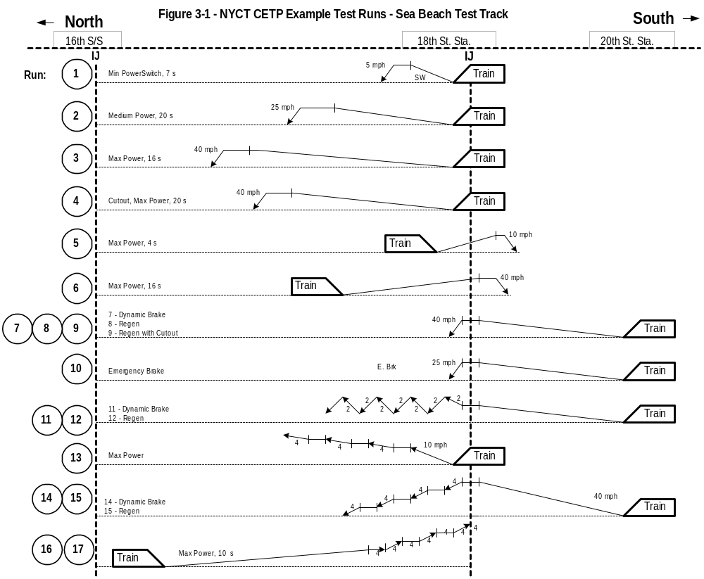

Figure 3-2 Example Test Run Log

Date: ____________________________________________________________ Performed By: ___________________________________________________________________

Train Configuration: _______________________________________________ Track Circuit Configuration: ______________________________________________________________

Test Run ID | Test Type | Time | Tape ID / Plot ID /  Stripchart ID | Train Configuration, Faults, and Notes | From / To / Note or  Playback Mode | Results
Tape
Plot
Strip
Tape
Plot
Strip
Tape
Plot
Strip
Tape
Plot
Strip
Tape
Plot
Strip
Tape
Plot
Strip
Tape
Plot
Strip
Tape
Plot
Strip
Tape
Plot
Strip
Tape
Plot
Strip

Recommended Conducted EMI Test Method and Test Equipment Configuration

The following sections detail the recommended Conducted EMI Test Procedure, the CETP test equipment setup, and brief descriptions of the recommended test equipment.

Section 4.1 describes the recommended test procedure. Section 4.2 describes test equipment items referenced by acronym or name in section 4.1. Section 4.3 describes the EMI Test Adapter (ETA), which provides useful signal processing functions in the test.

Recommended Conducted EMI Test Procedure

The carbuilder shall perform a Conducted EMI Test which complies with the Carbuilder CETP and with the following Recommended Conducted EMI Test Method. In the test, the carbuilder shall demonstrate that the train's worst-case emissions do not disturb the worst-case track circuits, with the required margin.

To accomplish this, the carbuilder operates the train to produce worst-case emissions, as described in CETP section 2.2.1. The carbuilder operates the train in each of the worst-case track circuits. The worst-case track circuits, provided by NYCT, are described in CETP section 6.5. A test instrument setup, described in this section and in CETP section 4.2, monitors and records the current in the track relay, called the In-Circuit Relay.

During playback, the test setup plays back and amplifies the monitored In-Circuit Relay voltage by a specified gain, and drives the amplified signal into a separate track relay, called the Margin Test Relay.

At the first playback stage, the entire test run is played back ten times at the level specified in the AC Train EMC Standards for Harmonic and Repeating Broadband emissions (presently 4x or 12 dB). Any emission which fails the playback at the Harmonic and Repeating Broadband level is evaluated to see it if qualifies as an Impulse emission. If it is qualified as an Impulse, it is played back ten times at the Impulse emission level specified in the AC Train EMC Standards (presently 2x or 6 dB).

An AC Train is EMC qualified if its worst-case emissions, amplified to the level specified for the type of emission in question, do not disturb the normal operation of the Margin Test Relay in ten playbacks.

NYCT installs the worst-case track circuits on the Sea Beach Test Track or the Dyre Avenue Test Track, as described in section 6.5. For the Sea Beach Test Track, the track circuits are near and accessible from the 16th Avenue Substation on the Sea Beach N Line, track E4. For the Dyre Avenue Test Track, the track circuits are near and accessible from the Baychester Substation on the Dyre Avenue Line, track Y3.

In the following recommended test procedure, the carbuilder may request authorization from NYCT to use alternative equipment, configuration, or procedural steps. For NYCT to consider authorization of the alternative, the carbuilder must document that the alternative provides equivalent results to the recommended method, to the satisfaction of NYCT.

The recommended Conducted EMI Test Method consists of the following steps:

CET1 Equipment Setup: Set up the Conducted EMI Test per Figure 4-1.

CET1.1 Set up the In-Circuit Relay, Margin Test Relay, EMI Test Adapter (ETA), instruments, and other items per Figure 4-1a. Figure 4-1b highlights the connection points to the ICR and MTR for the worst-case track circuits. Figure 4-2 shows the ETA block diagram. Table 4-1 below shows the filter settings. Figure 4-3 shows the equipment list and provides notes on major items.

Table 4-1
Bandpass Filter Settings
Track Circuit | High Pass | Low Pass
25 Hz | 8 Hz | 75 Hz
60 Hz | 20 Hz | 200 Hz

Hook up sensitive signals using coax or twisted pair wiring. Set length and routing of and cable runs to minimize pickup loops. Position sensitive instruments far from higher power equipment.

For the V-rail signal recorded by the DAT recorder, the carbuilder may use V-rail-att, as shown in Figure 4-1a. Alternately, the carbuilder may additionally record and use for playback the output of the first, high pass stage of the Krohn-Hite filter, which strips of the DC component of the track signal. If the carbuilder uses the high-pass-filtered version of V-rail-att (V-rail-att-HP), the DAT recording should also contain the unfiltered V-rail-att.

CET1.2 Confirm and document correct operation of all instruments, track circuits, regeneration resistor bank, and other equipment. NYCT Signal Operations will install the selected worst-case track circuits in the test track. NYCT Signal Operations will connect and adjust each track circuit for worst-case operation suitable for testing.

CET1.3 Set up the ETA switches as follows: Power On; Preamp Gain to 0 dB position; Track Occupied V-rail-fltrd Phase knobs to 0º position; 0º/180º switch to 0º; Track Occupied V-rail-fltrd Gain knobs to 1.00 position; Track Occupancy Mode to the None position.

Section 4.3 describes the ETA, inputs and outputs, controls, and provides its schematic diagram.

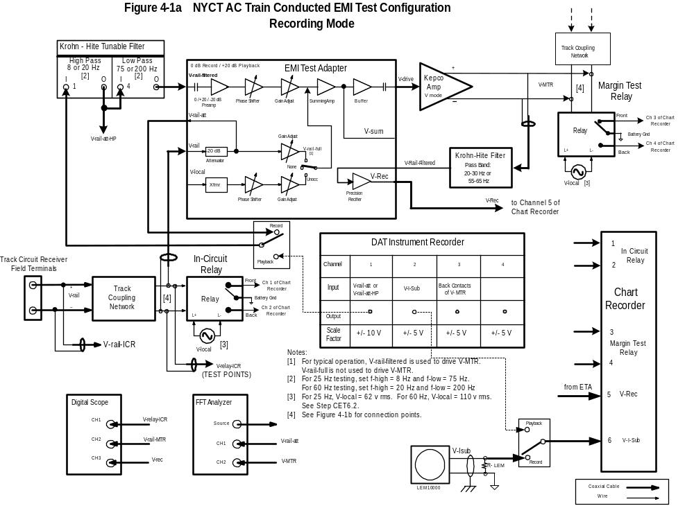

Figure 4-1b
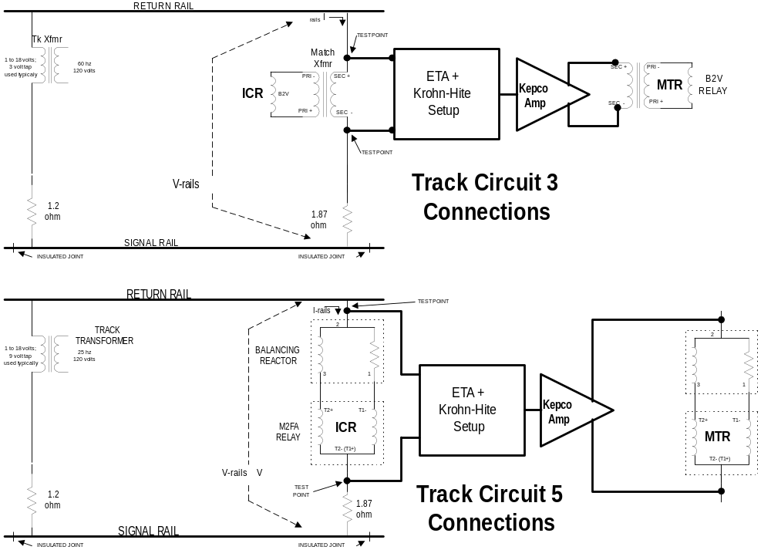

Figure 4-2

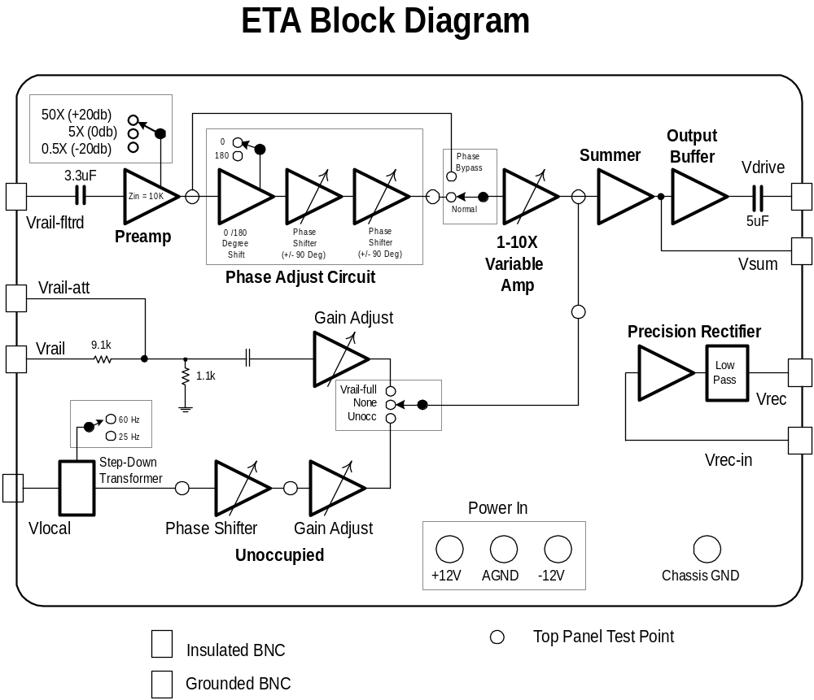

Figure 4-3
Conducted EMI Test Equipment List
# | Item | Note
1 | Dual Channel Signal Analyzer, HP 35670A or equiv. | For measuring emission signals, typically FFT spectra
2 | Printer, Plotter, or HP 2225A Inkjet Printer, or equiv. | For plotting emission spectra
3 | DAT Recorder, Teac RD-130T, or equiv. | For recording emission signals for later playback
4 | Audio Signal Generator | For placing calibration current in I-sub current monitor
5 | Kepco BOP 20-20M | For driving the amplified current in the Margin Test Relay. May be available from NYCT.
6 | 2 each Krohn-Hite Programmable Filter, Model 3384 or equiv. | For selecting frequency bands of interest.
7 | Dual Power Supply for LEM  +/- 55 Vdc | Power supply for LEM current monitor
8 | LEM High Current Probe for I-sub | For monitoring substation current.
9 | 2 each Low Current Probe for I-relay  E.g., LEM small current probe or  Bell current probe | For monitoring relay current.
10 | EMI Tester Adapter | For monitoring, scaling, amplifying, buffering, summing, and driving signals. Schematics included in CETP. May be available from NYCT.
11 | Multi-Channel Chart Recorder | For recording ICR and MTR relay operation and substation current.
12 | Battery Pack with Pull up Resistors for Track Relay contact monitoring
13 | Table and chairs  Rubber Mats
14 | 110 vac Isolation Transformers | To control ground current loops
15 | Oscilloscope | To adjust MTR and ITR
16 | 0.06 Ohm Shunt | To set up track circuit
17 | Rail clamps for signal connection
18 | DVM
19 | 110 vac Power Strips and extension cords
20 | Test leads and hookup wire
21

CET2 Calibrate Instruments With Known Signals: Perform and document an initial calibration which demonstrates that the Digital Audio Tape Recorder (DAT) both in record and playback mode, the Strip Chart, the Signal Analyzer, the ETA, the transducers, and external instruments, as shown in Figure 4-1, give correct, accurate, and repeatable results. Set the DAT to record with a bandwidth of at least 10 kHz per channel. Document the gain constants, scale factors, and signal levels for all recorded and monitored parameters and signals. Figure 4-4 shows suggested levels for recording and playback.

CET3 Set MTR: Set the Margin Test Relay (MTR) track coil voltage and phase by adjusting the
ETA.

CET3.1 Use the FFT Signal Analyzer to generate a swept V-rail signal in the ICR and measure the signal in the MTR. Use the FFT Signal Analyzer to confirm that the frequency response of the transfer function { V-rail-MTR / V-rail-ICR } is sufficiently flat in the band of interest, e.g., +/- 1.0 db.

CET3.2 Turn on the In-Circuit Transmitter. Remove the train from the track circuit. Set up the ICR track circuit unoccupied, per NYCT standard.

CET3.3 Set the ETA Track Occupancy Mode switch to the None position. Adjust the ETA V-rail-fltrd Phase and Level Adjustments so the phase and amplitude of the MTR I-relay and V-rail equal those for the ICR, using an oscilloscope and FFT analyzer. Make sure there is no clipping of the signals in the ETA or Kepco Amplifier. Record the values.

CET3.4 Turn the In-Circuit Transmitter on and off. Observe that the pickup and dropout response of the ICR and MTR are the same.

CET4 Set up Chart Recorder: Set up the chart recorder to record, at a minimum, the following:

- MTR relay contacts
- ICR relay contacts
- V-Isub. V-Isub is the substation current.
- V-Rec. V-Rec is the precision rectified version of V-rail, optionally filtered to restrict its bandwidth to around the relay operating frequency. The ETA and Krohn-Hite filter combination or another type of filter/detector can be used to generate the V-Rec signal.

Figure 4-5 shows an example strip chart for a test run.

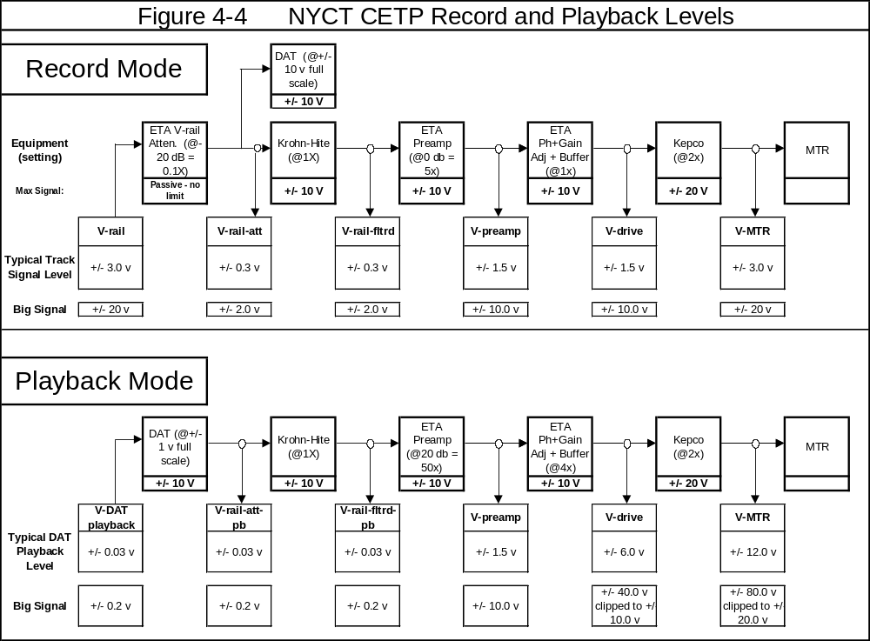
Figure 4-5 Strip Chart Example

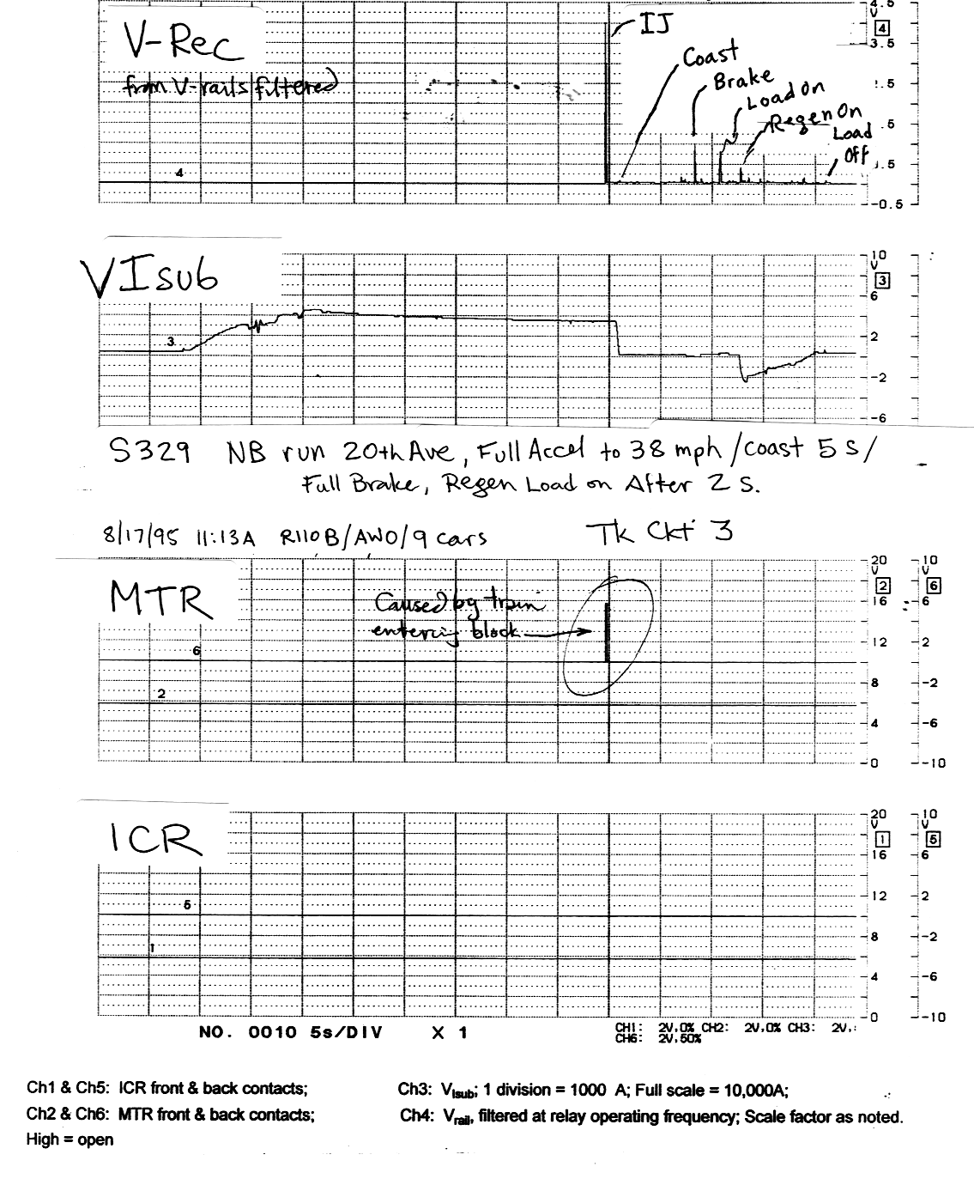

CET5 Confirm Correct Operation and Calibrate DAT With Track Signals: Set up the DAT Recorder and Signal Analyzer to record V-rail-att, V-Isub, V-rail-ICR, and V-rail-MTR. Make sure there is no clipping of the signals in the DAT or FFT Signal Analyzer. Use the DAT, FFT Signal Analyzer, and Strip Chart to record all runs. Figure 4-6 shows an example Signal Analyzer plot for a test run.

CET5.1 Use the DAT and FFT Signal Analyzer to record the track signal for several conditions shown in Table 4-2:

Table 4-2

Track Signal Calibration Conditions
Case | ICR TX | ICR Local | Condition
1 | On | On | Normal unoccupied track circuit
2 | Off | On | Test Coupling of local voltage to V-rail
3 | Off | Off | Confirm 60 Hz or 25 Hz noise floor is low enough

Confirm that the level of 60 Hz or 25 Hz pickup and other instrumentation noise is low enough to permit good recording and playback of actual and amplified 60 Hz and 25 Hz V-rail signals.

CET5.2 Reconfigure the test setup for playback per Figure 4-7. Playback the DAT tape and make FFT plots. Confirm and document that the playback FFT plots reproduces the original FFT plots with adequate accuracy for each condition.

CET5.3 Observe and document that no clipping occurs anywhere in the EMI instrumentation path during worst case runs, including in the LEM current transducers, filter inputs and outputs, ETA, Kepco amplifier, and DAT. Clipping could be caused either by peak third rail DC and substation harmonic currents or by train EMI currents. If clipping does occur, for example in the Kepco during major impulses, it should be momentary, and should not extend longer than the peak portion of the impulse. Note any clipping that does occur in the test log.

CET5.4 Using the procedure in step CET6, observe, record, and document the emissions from a train operating into and out of the test track circuit, using the FFT Analyzer and the DAT Recorder. Using the procedure in Step CET7, playback the recording with the Noise Gain Knob set to 1x. Document that the recorded and playback signals are essentially identical.

Figure 4-6 FFT Plot Example

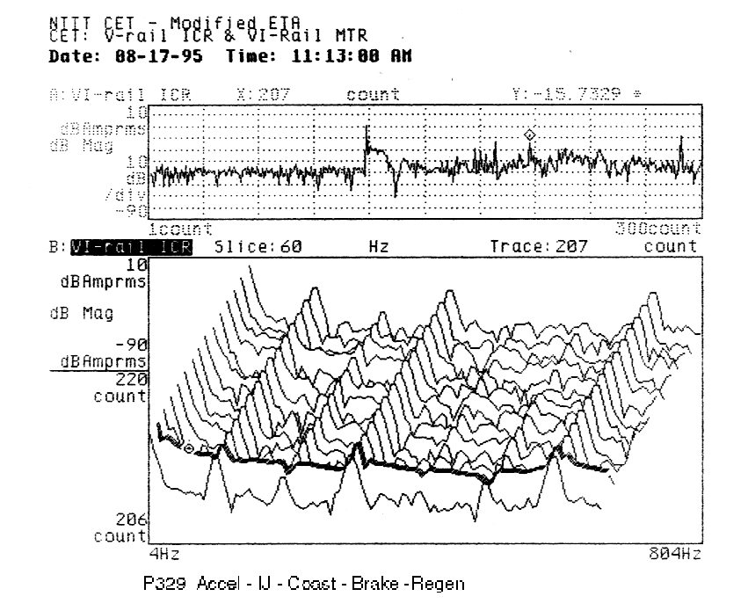

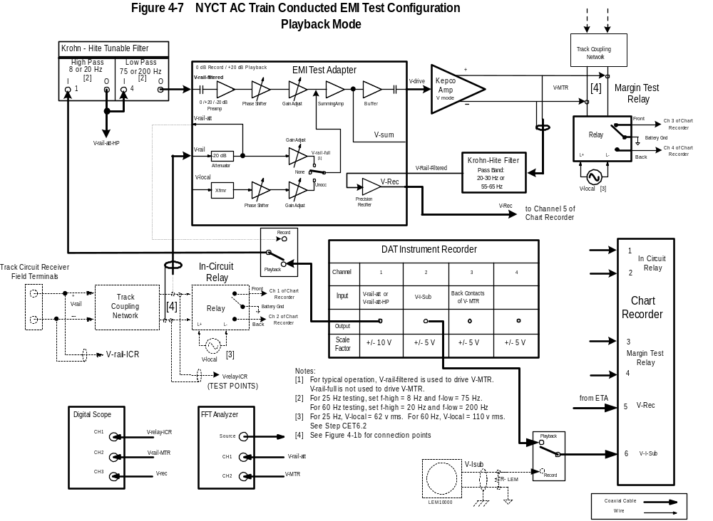

CET5.5 Position a train with one car inside the transmit end of the block, charged up and standing by. Using the regeneration load, draw zero, low, medium, and high levels of current from the substation. Using the procedure in step CET6, observe, record, and document the resulting 60 Hz component of V-rail track circuit receiver voltage under these conditions, using the FFT Analyzer and the DAT Recorder. Using the procedure in Step CET7, playback the recording with the Noise Gain Knob set to 4x. Document the baseline interference level due to the substation 60 Hz component.

CET6 Collect Occupied Test Data: Collect test data by operating the train under test to produce worst-case emissions in the occupied worst-case track circuit.

CET6.1 Set the ETA Track Occupancy Mode switch to the None position. Connect test leads from the V-rail BNC on the ETA across part or all of the track coupling network on the receiving end of the track circuit, as shown in Figure 4-1b or as otherwise approved. Set the ETA Preamp switch to 0 dB position and turn the Noise Gain knob to the 1.0 position.

CET6.2 Turn on the In-Circuit Transmitter. This models the in-service situation and also indicates track occupancy status on the strip chart during testing. Turn off the ICR Local Voltage, per Table 4-3, to eliminate voltage coupling from the ICR Local winding to the ICR Track winding during the test. Since the ICT Local Voltage is off, the ICR will not pick up or operate during these tests. However, the MTR should operate normally, picking up and dropping out as the train clears and occupies the block.

Table 4-3

Occupied Case ICR and MTR Connections for Recording
ICR TX | ICR Local | MTR Local
On | Off | On

CET6.3 Run the train under test in the applicable operating modes, speeds, train lengths, and loading to determine worst-case for V-rail interference currents. Monitor the relays; observe whether the MTR opens a back contact or closes a front contact; and note whether either relay has visible armature movement.

CET6.4 During test runs, MTR contact closures often occur when the train enters the track circuit or when the regeneration load is switched on or off. These events reflect track and test characteristics, rather than train emissions. Note these events on the stripchart. As long as the block entry or regeneration load events can be clearly distinguished from events such as propulsion system mode transition, exclude them from consideration during later playbacks. Figure 4-5 shows an example of an MTR relay contact closure when the train enters the block, along with other EMI events. The relay response when the train entered the block is acceptable.

CET7 Playback Occupied Data and Check Margin: Set up the Conducted EMI Test per Figure 4-7. Playback data from the noisiest runs to find the margin of operation for the Occupied track circuit case.

CET7.1 Select the worst-case run recordings for further analysis. Worst-cases were those with the most intense relay action or highest relay currents.

CET7.2 Disconnect the V-rail connection from the ETA. Set up for playback, as shown in Figure 4-7.

Set the Preamp Gain switch to the appropriate position so the playback level at the MTR is equal to the ICR level, when the Noise Gain knob is set to 1.0x. If the DAT playback level is –20 dB below the DAT recording level, the Preamp Gain is typically set to the +20 dB position to compensate for the –20 dB DAT recording / playback attenuation. If the DAT playback level is at the same level as the recording level, the Preamp Gain switch is typically set to the 0 dB position.

Set the ETA Track Occupancy Mode switch to the None position.

CET7.3 Set the Noise Gain knob to the level specified in the NYCT EMC Standard for Harmonic or Repeating Broadband emissions (presently 4x or 12 dB). Playback the entire recording to identify all disturbances for consideration and analysis. Use the strip chart and FFT Signal Analyzer to record test results. Observe V-rail-MTR on the oscilloscope and FFT Signal Analyzer.

The test shows that all train emissions are acceptable if the MTR does not open a back contact or close a front during ten playbacks of the tape. The Noise Gain knob setting indicates the operating margin for the train emission in the test track circuit.

Certain Impulses identified in Table 2-1 are test artifacts and are not relevant to EMI qualification of an AC Train. These include rail gap, normal shoe bounce, track circuit entry or exit, regen load on, and regen load off. Additionally, key on, emergency brake, and high speed circuit breaker trip may be excluded from further consideration if their duration is acceptable to NYCT. Any such Impulse must be identified as such on the strip chart.

CET7.4 If certain portions of the playback tape did not pass with the Noise Gain knob set to the level specified in the NYCT EMC Standard for Harmonic or Repeating Broadband emissions, those portions of the playback must be evaluated to see if they qualify as Impulse emissions. Section 2.2.4 and Figure 2-1 give the criteria for evaluating whether an emission is an Impulse.

Retest Harmonic or Repeating Broadband emissions which do not qualify as Impulses to determine the actual margin for these emissions, by playing back the appropriate portion of the recording with the Noise Gain knob set to varying levels. Report the actual level for the non-compliant Harmonic or Repeating Broadband emissions to NYCT.

Retest emissions which qualify as Impulses by playing back the appropriate portion of the recording with the Noise Gain knob set to the level specified for Impulses (presently 2x or 6 dB).

As before, playback the recording. Use the strip chart and FFT Signal Analyzer to record test results. Observe V-rail-MTR on the oscilloscope and FFT Signal Analyzer.

The test shows that the Impulse train emissions are acceptable if the MTR does not open a back contact or close a front contact during ten playbacks of the tape.

Retest Impulse emissions which do not pass with the specified margin to determine the actual margin for these emissions, by playing back the appropriate portion of the recording with the Noise Gain knob set to varying levels. Report the actual level for the non-compliant Impulse to NYCT.

Note any test artifact relay events on the stripchart.

CET8 Test Unoccupied Condition: As directed by NYCT, playback data, or if necessary record and playback additional data, to test the Unoccupied track circuit case.

CET8.1 Select the worst-case run recordings for further analysis. Worst-cases are those with the most intense relay action or highest relay currents. For this purpose, the portions of the test run recordings can be used during which the train was outside the test track circuit.

If it is necessary to acquire more data to investigate train emissions in the Unoccupied condition, capture additional recordings with the ICR and MTR settings shown in Table 4-4 below. Test runs should be performed so the most intense emissions are generated when the train is just outside the test track circuit.

Table 4-4

Unoccupied Case ICR and MTR Connections for Recording
ICR TX | ICR Local | MTR Local
Off | Off | On

CET8.2 Disconnect the V-rail connection from the ETA. Set up for playback, as shown in Figure 4-7.

CET8.3 With the DAT recorder off, place the Track Occupancy Mode switch in the Unoccupied position. Adjust the Unoccupied Gain Adjust potentiometer and the Unoccupied Phase Adjust potentiometer so the level and phase of the MTR track signal match the normal unoccupied level and phase on the ICR. Confirm the correct operation of the MTR relay.

With the Track Occupancy Mode switch in the Unoccupied position, the ETA will output the appropriate voltage to pick up the track relay. In this position, the ETA will sum the normal track relay pickup voltage with the filtered, amplified V-rail noise signal.

CET8.4 Set the Preamp Gain switch to the appropriate position so the playback level at the MTR is equal to the ICR level, when the Noise Gain knob is set to 1.0x. If the DAT playback level is –20 dB below the DAT recording level, the Preamp Gain is typically set to the +20 dB position to compensate for the –20 dB DAT recording / playback attenuation. If the DAT playback level is at the same level as the recording level, the Preamp Gain switch is typically set to the 0 dB position.

CET8.5 Set the Noise Gain knob to the level specified in the NYCT EMC Standard for Harmonic or Repeating Broadband emissions (presently 4x or 12 dB). Playback the portion of the recording during which the train was outside the test track circuit to identify all disturbances for consideration and analysis. Use the strip chart and FFT Signal Analyzer to record test results. Observe V-rail-MTR on the oscilloscope and FFT Signal Analyzer.

The test shows that all train emissions are acceptable if the MTR does not open a front contact or close a back during ten playbacks of the tape. The Noise Gain knob setting indicates the operating margin for the train emission in the test track circuit.

Certain Impulses identified in Table 2-1 are test artifacts and are not relevant to EMI qualification of an AC Train. These include rail gap, normal shoe bounce, track circuit entry or exit, regen load on, and regen load off. Additionally, key on, emergency brake, and high speed circuit breaker trip may be excluded from further consideration if their duration is acceptable to NYCT. Any such Impulse must be identified as such on the strip chart.

CET8.6 If certain portions of the playback tape did not pass with the Noise Gain knob set to the level specified in the NYCT EMC Standard for Harmonic or Repeating Broadband emissions, those portions of the playback must be evaluated to see if they qualify as Impulse emissions. Section 2.2.4 and Figure 2-1 give the criteria for evaluating whether an emission is an Impulse.

Retest Harmonic or Repeating Broadband emissions which do not qualify as Impulses to determine the actual margin for these emissions, by playing back the appropriate portion of the recording with the Noise Gain knob set to varying levels. Report the actual level for the non-compliant Harmonic or Repeating Broadband emissions to NYCT.

Retest emissions which qualify as Impulses by playing back the appropriate portion of the recording with the Noise Gain knob set to the level specified for Impulses (presently 2x or 6 dB).

As before, playback the recording. Use the strip chart and FFT Signal Analyzer to record test results. Observe V-rail-MTR on the oscilloscope and FFT Signal Analyzer.

The test shows that the Impulse train emissions are acceptable if the MTR does not open a front contact or close a back contact during ten playbacks of the tape.

Retest Impulse emissions which do not pass with the specified margin to determine the actual margin for these emissions, by playing back the appropriate portion of the recording with the Noise Gain knob set to varying levels. Report the actual level for the non-compliant Impulse to NYCT.

Note any test artifact relay events on the stripchart.

CET9 Test Other Track Circuits: Reconfirm the setup calibration, per step CET2. Repeat steps CET3 - CET8 for worst-case track circuits #3 and #5, and others per NYCT direction, per CETP section 6.5.

CET10 Test Report: Prepare a Test Report as required in CETP section 5.

Field Test Equipment Arrangement

Figure 4-1 shows the Field Test equipment arrangement during recording. Figure 4-7 shows the Field Test equipment arrangement during playback. Section 4.1 describes the procedure for recording and playback.

In the following description of equipment, the carbuilder may propose use of an equivalent item. For NYCT to accept the alternative, the carbuilder must document that the proposed item provides equivalent results to the recommended item, to the satisfaction of NYCT.

Typical major test equipment items are:

EMI Test Adapter

The EMI Test Adapter (ETA) provides buffering, scaling, adjustable gain and phase, selectable gain, bandpass filtering, and rectifier functions required in the Recommended Conducted EMI Test Method.

The ETA processes the In Circuit Relay (ICR) voltage, V-rail, which contains the conducted EMI noise signal. The ETA can combine the amplified processed ICR voltage, V-rail-fltrd, with the unprocessed track voltage, V-rail-full, or with a track signal of selected amplitude, frequency, and phase. The ETA drives the combined signal into the Kepco Bipolar Power Amplifier at the suitable level.

Section 4.3 provides a more detailed description of the ETA.

Kepco Bipolar Power Amplifier

The Kepco Bipolar Power Amplifier accepts the combined track signal from the ETA and drives the Margin Test Relay (MTR) Track Coupling Network or Relay, at the selected output level. The Kepco provides a fixed gain of 2x of the input signal received from the ETA.

The Kepco Bipolar Amplifier Model BOP 20-20M provides an output of up to +/- 20 Vdc peak and +/- 20 Adc peak, at frequencies from dc up to around 8 kHz. Since this Kepco Amplifier has a 2x gain in the Voltage Mode and the maximum output level is +/- 20 Vdc, the input level must be limited to +/- 10 Vdc peak to prevent clipping.

The suggested arrangement uses the Kepco is used in the voltage mode, where its output voltage is proportional to the input voltage signal, which is the V-rail signal across part or all of the ICR. Some past tests have shown the Kepco is more stable and has better impulse response characteristics when using the voltage mode to drive the inductive load of the MTR. When the Kepco is used in the voltage mode, a compensation capacitor is not needed to stabilize the Kepco impulse or continuous wave signal response.

However, the carbuilder may choose to use the Kepco in the current mode, in which the output current is proportional to an input current, which is the current in the track coil of the ICR relay. If the carbuilder chooses to use the current mode, the carbuilder shall use the appropriate compensating capacitor or network on the Kepco to assure and demonstrate stability and signal response. The carbuilder shall demonstrate that the end-to-end impulse and continuous wave signal response of the ETA, Kepco, and MTR is adequate to perform the specified testing and reproduce the impulses well enough to determine the AC Train emission characteristics.

The Kepco should be positioned several feet away from the parts of the test setup with low-level signals, since the Kepco is a high power amplifier that generates stray magnetic flux at both power line harmonic frequencies and frequencies present in the input signals. This flux can induce noise in nearby instrumentation.

Krohn-Hite Tunable Filter

The Krohn-Hite tunable filter is used in this test to filter out traction power harmonics in the V-rail signal which are not relevant to EMI qualification of the train. For instance, the 360 Hz and 720 Hz traction power harmonics in V-rail are much stronger than the 60 Hz interference signals of interest in the 60 Hz track circuit. Because the Kepco's dynamic range is limited, this test arrangement suppresses the traction power harmonics, to permit undistorted amplification of the lower level signals of interest at 25 Hz and 60 Hz.

The Krohn-Hite tunable filter has two identical filter sections which can be configured independently as a low pass or high pass filter with frequency ranging from 0.1 Hz to 200 kHz. Each filter section has a built in gain adjustment of either 0 dB or +20 dB and can be configured as a Butterworth or Maximally Flat Bessel filter.

For the CETP, the two sections of the Krohn-Hite tunable filter are configured as a band pass filter. The first section is configured as a high pass filter with 0 dB gain, and a cutoff frequency of 8 Hz for the 25 Hz track circuits and 20 Hz for the 60 Hz track circuits. The second section is configured as a low pass filter with 0 dB gain and a frequency cutoff at 75 Hz for the 25 Hz track circuits and 200 Hz for the 60 Hz track circuits. See Table 4-4 below.

Table 4-4
Bandpass Filter Settings
Track Circuit | High Pass | Low Pass
25 Hz | 8 Hz | 75 Hz
60 Hz | 20 Hz | 200 Hz

The Krohn-Hite tunable filter accepts a V-rail-att signal of up to +/- 10 Vdc peak from the ETA. The filter output drives the ETA with a bandpass filtered signal V-rail-fltrd, with maximum amplitude +/-10 Vdc peak.

Other filters, such as the Krohn-Hite tunable filter Model 3384, can serve the same function. This model has four separate channels instead of two, and probably has lower residual 60 Hz noise. It includes a digital display of frequency with resolution as low as 0.001 Hz. Memory storage for frequently used settings is also available with this newer model. The filter should have an input and output capable of handling signals of +/- 10 Vdc peak.

Digital Audio Tape (DAT) Recorder

The DAT Recorder records test run signals V-rail-att(ICR), V-rail-fltrd(ICR) or V-rail-att-HP, V-rail-MTR, and V-Isub, for later playback. With the recorded information, any run can be repeated on the test bench as many times as needed without the need of the field equipment such as trains, crew, test setup, etc.

For confidence in the results, the signals from each test run of interest should be played back ten times, to ensure that all possible phase relationships between the V-rail signal and the MTR local voltage are tested. During playback, the ETA provides selectable gain for V-rail signals.

A Teac Model RD-130TE, eight channel DAT Recorder may be used. This DAT provides selectable input scale factors of +/-2V, +/-5V, +/-10V, or +/-20V, and a fixed output level of +/-2V. The bandwidth for these channels is set from a maximum of 20 kHz to 5 kHz, depending on how many channels are used. Figure 4-1 shows the signal names and channel assignments.

In a typical use, the maximum recorded signal levels require that the DAT input scale factor be set to a level greater than +/-2V. It is convenient to choose an input scale factor that is -20 dB from the DAT's standard fixed output max level. If the DAT's fixed output maximum is +/- 2v, the input scale factor should be set to +/- 20 v. That way, it is convenient to exactly compensate for the -20 dB record / playback difference using the ETA switch.

If the recorder used by the carbuilder can accept the biggest V-rail signal without clipping, and still play back at 0 dB, then the ETA switch should be set in the 0 dB position rather than the +20 dB position during playback.

Multi-Channel Chart Recorder

A Multi-channel Chart Recorder records time-varying information for each run. These recorded signals are V-Rec, the rectified frequency component of the track circuit receiver voltage; substation current V-Isub; ICR front and back contact position; and MTR front and back contact position. A Soltec Multi-Channel Chart Recorder Model TA-200-938 has been successfully used in previous tests. Figure 4-8 shows typical channel assignments. Figure 4-5 shows a typical strip chart output.

Figures 4-1 and 4-7 show the connections from other test equipment to the chart recorder.

A six-volt battery box with pull-up resistors may connect to the chart recorder inputs for the four channels which record relay contacts. This battery and resistor combination provides a signal of +6 Vdc when the relay contacts are open. When the contacts are closed, the signal is grounded.

Figure 4-8
Typical Strip Chart Channels
Num | Name /  Source Connection | Analog / Digital | Max Amplitude | Typical Engineering Units
1 | ICR Front Contact /  relay terminal | Digital | 0 - 6 Vdc | +6 Vdc => open  0 Vdc => closed
2 | ICR Back Contact /  relay terminal | Digital | 0 - 6 Vdc | +6 Vdc => open  0 Vdc => closed
3 | MTR Front Contact /  relay terminal | Digital | 0 - 6 Vdc | +6 Vdc => open  0 Vdc => closed
4 | MTR Back Contact /  relay terminal | Digital | 0 - 6 Vdc | +6 Vdc => open  0 Vdc => closed
5 | V-Rec /  BNC at ETA | Analog | 0 - 12 Vdc | +10.0 Vdc => 7.0 V rms  0 Vdc => 0 V rms
6 | V-Isub /  Resistor at LEM | Analog | -12 - +12 Vdc | +10 Vdc => 10,000 A peak  -10 Vdc => -10,000 A peak

Oscilloscope

A digital oscilloscope such as the Tektronix Model TDS 420 Four Channel Digital Oscilloscope monitors the track signals V-rail and V-rail-MTR for clipping. The oscilloscope is also used to align the phase and amplitude of V-rail-ICR and V-rail-MTR.

Fast Fourier Transform (FFT) Signal Analyzer

A Hewlett-Packard FFT Signal Analyzer Model HP 35670A or equivalent performs the following tasks:

* Measure and document the transfer function for CET equipment, from input signal to output signal

* Provide a sweep signal necessary to measure current transducer transfer function

* Monitor V-rail-att, V-Irail, V-rail-MTR, or other signals in the frequency domain

* Monitor V-rail-att, V-Irail, V-rail-MTR, or any other signals in their frequency and time domain using the waterfall 3-D display function

* Provide and document conversion of measured signals into engineering units, such as transducer voltage to measured amperes, or input voltages or to ohms

* Permit comparison of amplitudes and phases of track signal such as V-rail-ICR and
V-rail-MTR

* Provide hard copy of crucial test information such as instantaneous train emission levels, or snapshots of events.

Figures 4-1 and 4-7 show the connections of signals from CET test equipment to the FFT Analyzer.

Audio Frequency Filter / Detector

An audio frequency filter / detector provides V-Rec, a signal whose amplitude is proportional to the level of a selected frequency component. This frequency of the filter / detector is set to 25 Hz during testing of the 25 Hz track circuits, and to 60 Hz during testing of the 60 Hz track circuits. The V-Rec output from this filter / detector is recorded on the stripchart recorder; and it provides the graphical indication of where and when a train’s emissions in the band of interest are highest.

The suggested audio frequency filter / detector is implemented using the ETA plus Krohn-Hite. The Kepco output V-MTR which drives the MTR is also connected to the input of a Krohn-Hite filter, which is set up as a bandpass filter at the center frequency of the relay under test, with a bandwidth of 10 Hz. The output of the Krohn-Hite filter, V-MTR-fltrd, is connected to the V-Rec-in input of the ETA. The ETA precision rectifier circuit and low pass filter detect and output the V-Rec signal.

An alternative audio frequency filter / detector can be implemented several ways:

PC Based Data Acquisition System: A personal computer based data acquisition system can provide the bandpass filter and signal detector necessary to create the V-Rec signal.

3581A: The Hewlett Packard Model 3581A is an audio frequency wave analyzer. It is similar to the HP 3580A audio frequency spectrum analyzer, except that its front panel has a meter rather than a video display. Some models of the HP 3581A provide a digital indicator of the center frequency. The V-Sum signal at the output of the ETA is fed to the input of this wave analyzer. Set the center frequency to 60 Hz or 25 Hz, as appropriate to the relay under test. Set resolution bandwidth to 10 Hz. Set span to 0 Hz. The penplotter Y output of the wave analyzer provides a rectified DC level proportional to the selected signal component at the input. A HP 3580A audio frequency spectrum analyzer can also perform the same function as the HP 3581A wave analyzer. It is necessary to monitor the HP 3581A to be sure its center frequency has not drifted.

The Krohn-Hite Filter is more stable in its frequency selectivity than the HP 3580A or the HP 3581A methods.

NYCT Signals Track Coupling Network and Relays

Section 6.2 describes the NYCT signals track coupling network, relays, and characteristics.

NYCT staff will set up each worst-case track circuit for use by the carbuilder in the AC train Conducted EMI Test. NYCT staff are responsible to confirm that the signal equipment is:

- In correct working order
- Has the correct response as identified on the relay nameplate
- Is fit to be used in the test.

Current Transducers

Current transducers measure dc and ac components of current in the substation feeder to the test track. A Liasons Electroniques Mechaniques (LEM) model LT 10000-S is permanently installed on the third rail feeder cable to the test track at both the Sea Beach and Dyre Avenue test tracks.

The LT 10000-S current transducer has a current rating of 10,000 A. It measures current in the range of +/-10,000 A with a +/- 0.3 % accuracy at 25 °C, and a frequency bandwidth of 100 kHz. It has a conversion ratio of 10,000:1. For the CET, it measures V-Isub, the substation current feeding the test track. The LEM 10000 is powered by a pair of power supplies, at between +/- 48 Vdc and +/-60 Vdc.

Using a 10 ohm current sensing resistor on the LEM output provides an output of 10 v peak for a current of 10,000 A peak, or a transfer ratio of 1000 A/V. For this use, the power supply should be above about +/- 55 vdc.

A typical calibration arrangement is to install a calibration coil with between 10 and 100 turns around the LEM. Use an ac voltage source and known resistor to provide a calibration current of known amplitude into the LEM. Confirm the calibration of the LEM. For example, a 1.0 V rms ac voltage across a 10 ohm resistor provides about a 100 mA current into a calibration coil. With 100 turns on the LEM, the calibration signal is 10 A equivalent, or 10 mV rms at the LEM output. Observe and confirm the calibration signal and LEM output signal with an oscilloscope and good quality rms-reading DMM.

The carbuilder may use a current transducer to measure I-rail, the receiver end track signal relay current, or the current elsewhere in the track signal relay matching circuit. A LEM LA600-T can be used for this purpose. The LA600-T current transducer has current rating of 600 A. It measures current in the range of +/- 1500 A with a +/- 0.5 % accuracy. It has a conversion ratio of 1,000:1. For the CET, the LEM 600 is powered by a dual voltage supply with +/-15 Vdc.

EMI Test Adapter

Functions

The EMI Test Adapter provides buffer, scaling, adjustable gain and phase, selectable gain, filter, and rectifier functions useful in the Recommended Test Method. The functions of the ETA are to:

- Receive the voltage V-rail across part or all of the track coupling network on the receiving end of the track circuit, per the suggested test configuration. Alternatively, the ETA could receive a signal from a current probe measuring I-relay. Either signal contains the conducted EMI noise signal in the track coil of an In-Circuit Relay under test.

- Provide a selectable gain amplification of the received signal to accommodate the current sensor or attenuated voltage.

- Create an adjustable level, adjustable phase Simulated Track Coil signal. The Simulated Track Coil signal is set to the most interference-sensitive operating level of the normal operating frequency of an in-service track circuit. The usual source of the Simulated Track Coil signal is the ICR Local Coil voltage.

- Sum together the selected-gain-amplified conducted EMI Noise Signal with the unamplified Simulated Track Coil signal

- Drive the summed signal into the Kepco Bipolar Power Amplifier at the suitable level. The Kepco drives a suitable amplified signal into a Margin Test Relay.

- Provide a precision-rectified version of the drive signal for filtering and monitoring.

Appendix B shows the block and schematic diagram of the EMI Test Adapter (ETA).

ETA Inputs and Outputs

The ETA provides the following inputs and outputs:

V-rail: BNC input to receive the voltage V-rail across part or all of the track coupling network on the receiving end of the track circuit. Typical track signal is +/- 3 V peak. Maximum acceptable input is +/-100 V peak. Signal is attenuated by 20 dB, and provided as an output at V-rail-att. Input impedance is 10k, with a high pass filter with a 3 dB cutoff frequency of 5 Hz.

V-rail-att: BNC, low impedance, DC coupled output of V-rail, attenuated by 20 dB. This signal drives the DAT recorder and external configurable filter.

V-rail-fltrd: BNC input to receive filtered V-rail signal from the output of an external, configurable filter. Maximum acceptable input is +/-10 V peak. Input impedance 10k, with a high pass filter with a 3 dB cutoff frequency of 5 Hz.

V-local: Insulated BNC input to receive the Local Coil Voltage, either 110 Vac, 60 Hz or 62 Vac, 25 Hz.

V-drive: BNC low impedance output to drive Kepco power amplifier. AC coupled output with high pass filter with a 3 dB cutoff frequency of 5 Hz.

V-Sum: BNC low impedance output to drive an optional external bandpass filter for monitoring the limited spectral content of the output.

Rec-In: BNC input to receive the direct or filtered V-Sum signal, for precision rectification. The precision rectified output is convenient to record on a chart recorder. Maximum acceptable input is +/-10 v peak. Input impedance 10k.

V-Rec: Precision rectified low impedance BNC output, with peak amplitude equal to Rec-In peak amplitude. Output is smoothed through a low-pass filter with a 3 dB cutoff frequency of 10 Hz.

Power In: DIN connector to receive +12, -12, and power supply circuit ground connections from external wall-mount power supply.

The ETA case is connected to the ETA power supply circuit ground. All BNCs except those noted as insulated BNCs have their shell connected to the ETA case and the ETA power supply circuit ground.

ETA Controls and Test Points

The ETA provides the following controls and settings:

Preamp Gain toggle switch: -20 dB (0.5x), 0 dB (5x), or +20 dB (50x). The preamp receives V-rail-fltrd, the filtered and attenuated V-rail voltage across part or all of the track coupling network on the receiving end of the track circuit. The toggle switch sets the preamp gain to match the recording or playback scale factor. The preamp output is a test point on the ETA box.

-20 dB Position: In the -20 dB position, the ETA accepts a V-rail-fltrd signal which is typically filtered and equal in amplitude to V-rail. The ETA and the Kepco amplifier together produce an output signal in the MTR track coil which is -20 dB compared to the V-rail-fltrd signal, when the Noise Gain Knob is in the 1.0 position. This position can be used to reduce the amplitude of a V-rail track signal.

0 dB Position: In the 0 dB position, the ETA accepts a V-rail-fltrd signal, which is the filtered and attenuated V-rail. The ETA in this position and the Kepco amplifier together produce an output signal which is equal in amplitude to the original input signal V-rail, when the Noise Gain Knob is in the 1.0 position. This is the normal setting for data collection and recording.

+20 dB Position: This is the normal setting for playback. In the +20 dB position, the ETA accepts a V-rail-fltrd signal typically from the DAT recorder in playback mode. The DAT recorder playback output signal is typically -20 dB compared to the original recorded signal. The ETA in this position and the Kepco amplifier together produce a playback signal which is equal in amplitude to the original V-rail signal, when the Noise Gain Knob is in the 1.0 position.

Noise Gain Knob: This is a ten turn pot which continuously adjusts the Noise Signal gain from 0x to 10x. The variable amplifier amplifies V-rail-fltrd, the filtered Noise Signal, to test the margin against incorrect relay operation. The dial setting indicates the voltage ratio between the input and output of the variable amplifier. The following Table 4-5 shows the representative incremental gain in dB. The Noise Gain output is a test point on the ETA box.

Table 4-5
Noise Gain
Gain (dB) | 0 | 1 | 2 | 3 | 4 | 5 | 6 | 7 | 8 | 9 | 10 | 11 | 12
Knob Setting | 1.00 | 1.12 | 1.26 | 1.41 | 1.58 | 1.78 | 2.00 | 2.24 | 2.51 | 2.82 | 3.16 | 3.55 | 4.00

0° / 180° toggle switch: This switch changes the phase of the V-rail-fltrd signal from 0° to 180°, depending on the position of the switch.

V-rail-fltrd Phase Adjust potentiometers: Each of these two pots adjusts the phase of the Noise Signal over a range of about 180° at 60 Hz.

The combination of the 0°/180° toggle switch and the two phase adjust potentiometers form a phase shift network that is capable over a range of approximately 360° at 25 Hz and exceeding 360° at 60 Hz.

The purpose of the phase control adjustments is to permit the testers to match the phase of the MTR output signal to the phase of the ICR track signal, when the track circuit is not occupied.

Local Voltage toggle switch: 60 Hz (1x) or 25 Hz (2x). Selects the input transformer connection gain for generating the Simulated Track Coil signal from the Local Coil voltage input. The Simulated Track Coil signal simulates the normal track signal current at the relay operating frequency.

The Local Coil Voltage is stepped down by 10:1 in the 60 Hz position or 5:1 in the 25 Hz position. This provides an ac signal of about 6 V rms which is phase and amplitude adjusted to create the Simulated Track Coil signal.

Track Occupancy Mode toggle switch: V-rail-full, NONE, or UNOCC. Selects which signal is summed in the Summer amplifier. The selected Simulated Track Coil signal is a test point on the ETA box.

In the V-rail-full position, V-rail-full, the unfiltered and attenuated Noise Signal, is summed with the V-rail-fltrd signal. The V-rail-full level can be adjusted by the V-rail-full Gain Adjust pot to provide a 0x to 10x gain, as described below. This signal is not filtered by the external, configurable filter, and contains the full spectrum of V-rail energy.

In the NONE position, no signal from this path is summed with the V-rail-fltrd signal.

In the UNOCC position, the Simulated Track Coil signal is summed with the V-rail-fltrd signal. The Simulated Track Coil signal simulates the normal track signal current at the relay operating frequency. The Simulated Track Coil signals phase and amplitude can be adjusted as described below using the Unoccupied controls.

Vrail-full Gain Adjust potentiometer: 0.0 - 9.9. This ten turn pot controls the level of V-rail, the unfiltered and attenuated Noise Signal, when the Track Occupancy Mode toggle switch is in the V-rail-full position.

Unoccupied Gain Adjust potentiometer: 0.0 - 9.9. This ten turn pot controls the level of the Simulated Track Coil signal when the Track Occupancy Mode toggle switch is in the Unoccupied position. Pot R9 and resistors R24 and R11 set the level so the MTR Track Coil current output varies between about 0.4 to 2.0 V rms over the adjustment range of the pot.

Unoccupied Phase Adjust potentiometer: This pot adjusts the phase of the Simulated Track Coil signal over a range of about 180º, when the Unoccupied controls are selected. If the desired phase is out of that range, the polarity of the Local Voltage input should be swapped.

Power: ON or OFF. Switches +12 Vdc and -12 Vdc power to circuits in box. Green LED indicates power is on.

Requirements for the Carbuilder Conducted EMI Test Report Submittal

The carbuilder shall document the test in a Carbuilder Conducted EMI Test Report compliant with the Carbuilder CETP and the following requirements, and submit it to NYCT for approval. In addition, the carbuilder shall provide a copy of the DAT tape recordings for each run to NYCT for future use and analysis.

The Test Report shall consist of sections including or equivalent to the following:

Introduction: The Introduction section provides the purpose, scope, applicable requirements, participants, reference documents including car configuration documentation, test procedure overview, and organization for the rest of the report.

Test Results and Conclusions: The Test Results and Conclusions section:

- Identifies the train's Propulsion, Braking, and Auxiliary worst-case conditions

- Documents the train's worst-case emissions for each condition. For conducted emissions, refer to categories at Section 2.2.4 of this NYCT CETP.

- States whether or not the worst-case emissions disturb each of the worst-case track circuits, with the required margin.

It summarizes the test schedule and scope; provides a top level index of all test runs; identifies, reference, and describes the most important results; and clearly states conclusions.

Train Configuration Under Test: The Train Configuration Under Test section specifies the as-tested configuration of the train relevant to EMI, including train configurations and number of cars, propulsion units, and auxiliary units; current and voltage ratings for power units; line filter parameters and other EMI-related devices; and the values of any items or parameters which could affect EMI performance, such as propulsion unit and propulsion controller firmware revision numbers and EMI Detector action setpoints.

The Train Configuration Under Test section may reference other documents previously submitted to NYCT such as a design document or a configuration control drawing to specify parameters.

Test Track: The Test Track section describes the as-tested test track configuration. This section notes any differences or modifications to the test track configuration described in section 6 of this report.

Test Equipment Configuration: The Test Equipment Configuration section describes the as-performed test equipment configuration, including a detailed connection diagram of the test equipment setup, the list of test equipment with model numbers, and instrument calibration dates.

The Test Equipment Configuration section provides complete information on the scale or conversion factors which apply to all test data, including transducer outputs, strip charts, Signal Analyzer plots, and tape recordings.

The Test Equipment Configuration section provides initial setup calibration data which demonstrates that the DAT both in record and playback mode, the Strip Chart, the Signal Analyzer, the ETA, the transducers, and external instruments give correct, accurate, and repeatable results.

Test Procedure: The Test Procedure section summarizes the test steps, and describe any differences between the "as-performed" test steps and the Carbuilder CETP.

Test Runs and Results: The Test Runs and Results section summarizes all data collected during the test. It includes a list, log, or index of all test runs, tape recordings, strip charts, and spectral plots. It includes the Date, Performed by, Location, and Train Configuration for all tests. For each test it provides the Test Run Number, Test Type, Time, IDs of tape, plot, and strip chart; Test Run description; test configuration data such as gain settings; summary result; and notes.

The Test Runs and Results section states the pass/fail results of the testing, and describes significant test results, conclusions, or considerations.

Test Data: The Test Data section provides all appropriate test data, such as strip charts, plots, logs, and other support information supporting the test results and conclusions.

The carbuilder shall annotate the strip charts so the usual test artifact events at block entry and turn-on of the regeneration load are identified, as well as train events such as mode transition and regeneration variation.

Conducted EMI Test Reference Information

Test Track Locations

Sea Beach Test Track

The Sea Beach Test Track is a section of track on the B Division N line track E4, from the New Utrecht station to south of the 22nd Avenue Station. The track condition permits operation by AW3 trains at speeds up to at least 40 mph. Figure 6-1 shows the general arrangement of the Sea Beach Test Track.

The track will contain a worst-case 60 Hz track circuit and a worst-case 25 Hz track circuit, set up for easy reconfiguration and testing. The 1,500 ft track circuit is between receiver end insulated joints at the 16th Avenue Substation and transmit end insulated joints south of the 18th Avenue Station. NYCT will install a 1,005 track circuit if it is required for 25 Hz track circuit tests. See Table 6-1 below.

Both running rails of the track circuit are equipped with insulated joints and bolted bond cables at each end of the track circuit. NYCT will install the track circuit connections so all the track circuit equipment is located in the substation. The track circuit feed is connected at the 18th Avenue or southern end of the track circuit, and the relay is connected at the substation or northern end of the track circuit.

NYCT has equipped the test track with a manually-controllable resistor load which enables regeneration during braking. The load is located in the 16th Avenue Substation. The load draws 3,000 amps under typical operating conditions with a 600 Vdc line. The load should not be energized for more than about 30 seconds continuously. The load is switched on by pressing a momentary button which operates a contactor. NYCT plans to install a new load capable of drawing up to 6,000 amps.

Arrangements must be made with the NYCT System Operator to configure the track and substation for EMC testing. During use as a test track power supply, NYCT configures the 16th Avenue Substation to isolate the E4 track from the other tracks and provide a separate single unit traction power supply to the E4 track. The E4 track is fed from one of the two 3 MW rectifier units of the 16th Avenue Substation, with no feed from adjoining substations or from the second unit at 16th Avenue. NYCT will adjust the test track feeder breaker trippoint to 11,000 amps for the test, to avoid overcurrent trip events during normal testing. The second unit at 16th Avenue and the adjoining substations to the north and south feed the revenue service tracks.

The NYCT Power Department crew must open a trackside-mounted switch to disconnect cross-connect cabling and enable correct operation of the regeneration load.

Figure 6-2 shows the arrangement of the 16th Avenue Substation.

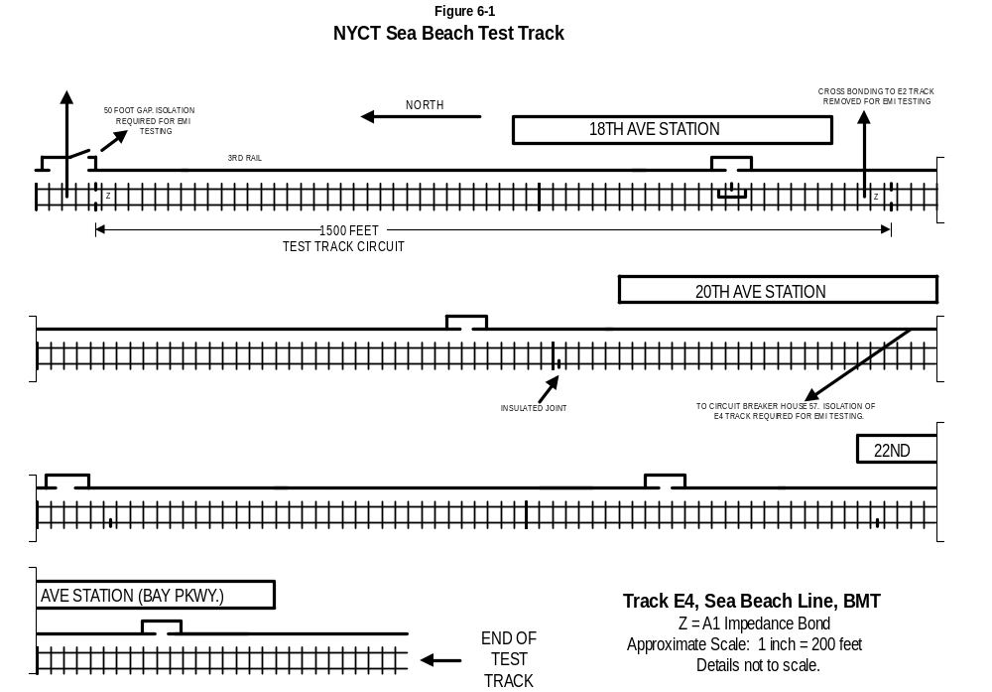
Figure 6-2

Sea Beach Substation Arrangement
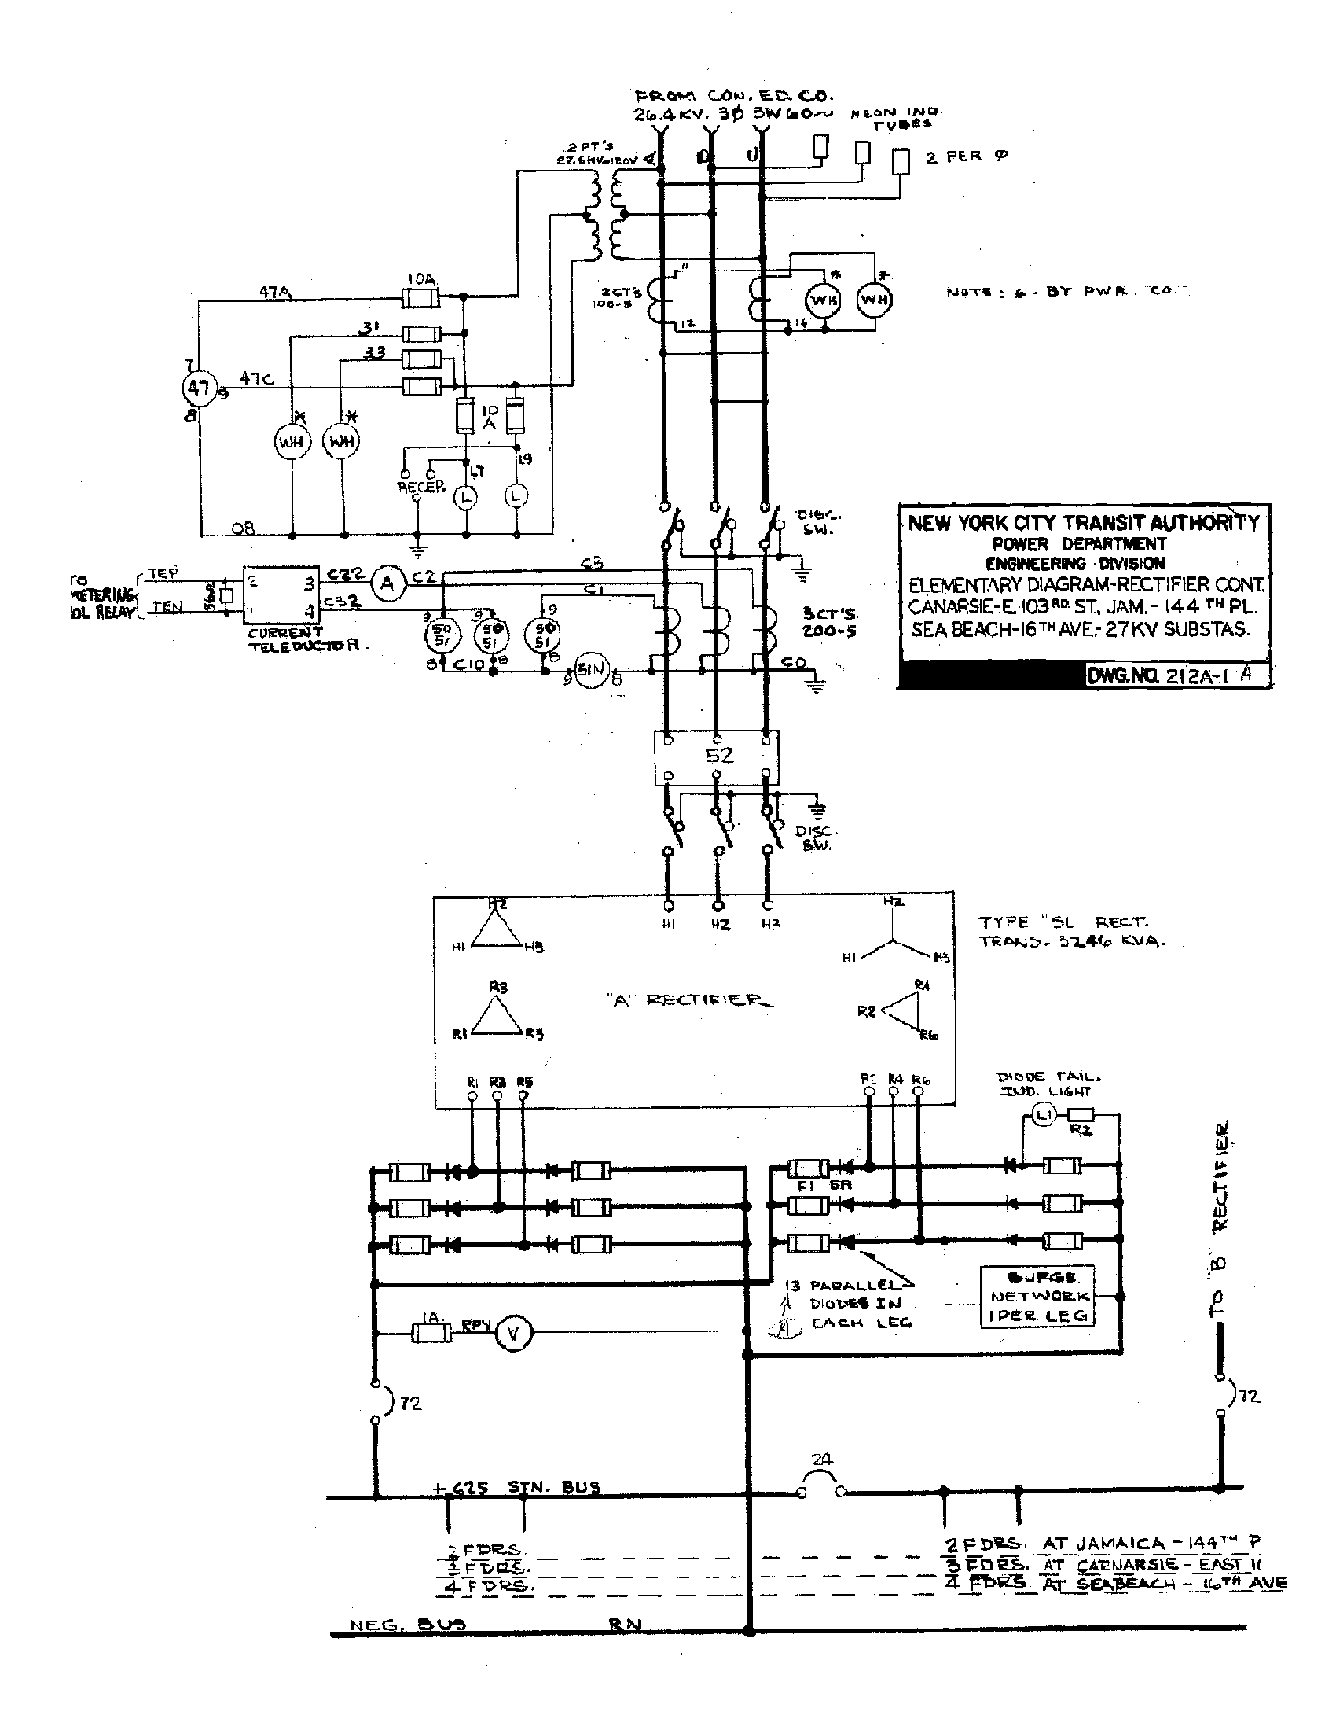

Dyre Avenue Test Track

The Dyre Avenue Test Track is a 15,400 ft section of track on the A Division Dyre Line track Y3, from just south of the Dyre Avenue Station to just south of the Morris Park Station. The track condition permits operation by AW3 trains at speeds up to 50 mph. Figure 6-3 shows the general arrangement of the Dyre Avenue Test Track.

The track will contain a worst-case 60 Hz track circuit and a worst-case 25 Hz track circuit, set up for easy reconfiguration and testing. The track circuit receiver end insulated joints are at stationing 295+00. The transmit end insulated joints are at stationing 280+00 for the 1,500 ft long track circuit. NYCT will install a 1,005 track circuit if it is required for 25 Hz track circuit tests. See Table 6-1 below.

Both running rails of the track circuit are equipped with insulated joints and bolted bond cables at each end of the track circuit. NYCT will install the track circuit connections so all the track circuit equipment is located in the substation. The track circuit feed is connected at the southern end of the track circuit, toward Gun Hill Road Station, and the relay is connected at the substation or northern end of the track circuit.

NYCT has equipped the test track with a manually-controllable resistor load which enables regeneration during braking. The load is located near the Baychester Substation. The load draws 2,000, 4,000, or 6,000 amps under typical operating conditions with a 600 Vdc line. The load should not be energized for more than about 30 seconds continuously. The load is switched on by pressing one or more momentary buttons which operate contactors.

Arrangements must be made with the NYCT System Operator to configure the track and substation for EMC testing. At the Dyre Avenue Test Track, the Y3 track is fed from the 3 MW Baychester Substation. Figure 6-4 shows the arrangement of the Baychester Substation. NYCT will adjust the test track feeder breaker trippoint to 11,000 amps for the test, to avoid overcurrent trip events during normal testing.

For conducted EMI testing, the NYCT System Operator should disconnect Baychester so it does not feed either revenue service track. Allerton, the next substation to the south, cannot be connected to the Y3 track, and it continues to power the revenue service tracks. The second substation to the south, Brady, is far enough away that it does not affect testing, though it may be disconnected from Y3 if the carbuilder prefers. To the north, confirm that the Secor substation is disconnected from the Y3 track by an existing isolation at 37 Switch, Dyre Interlocking.

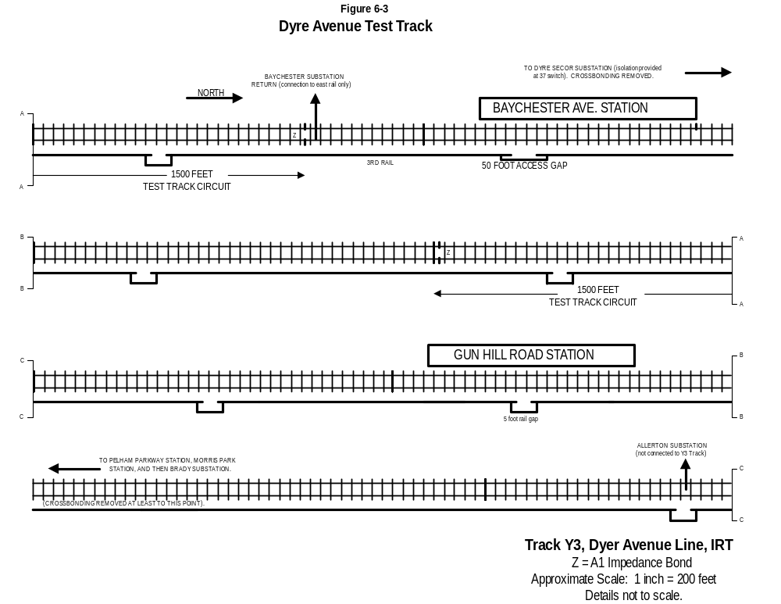
Figure 6-4

Baychester Substation Arrangement
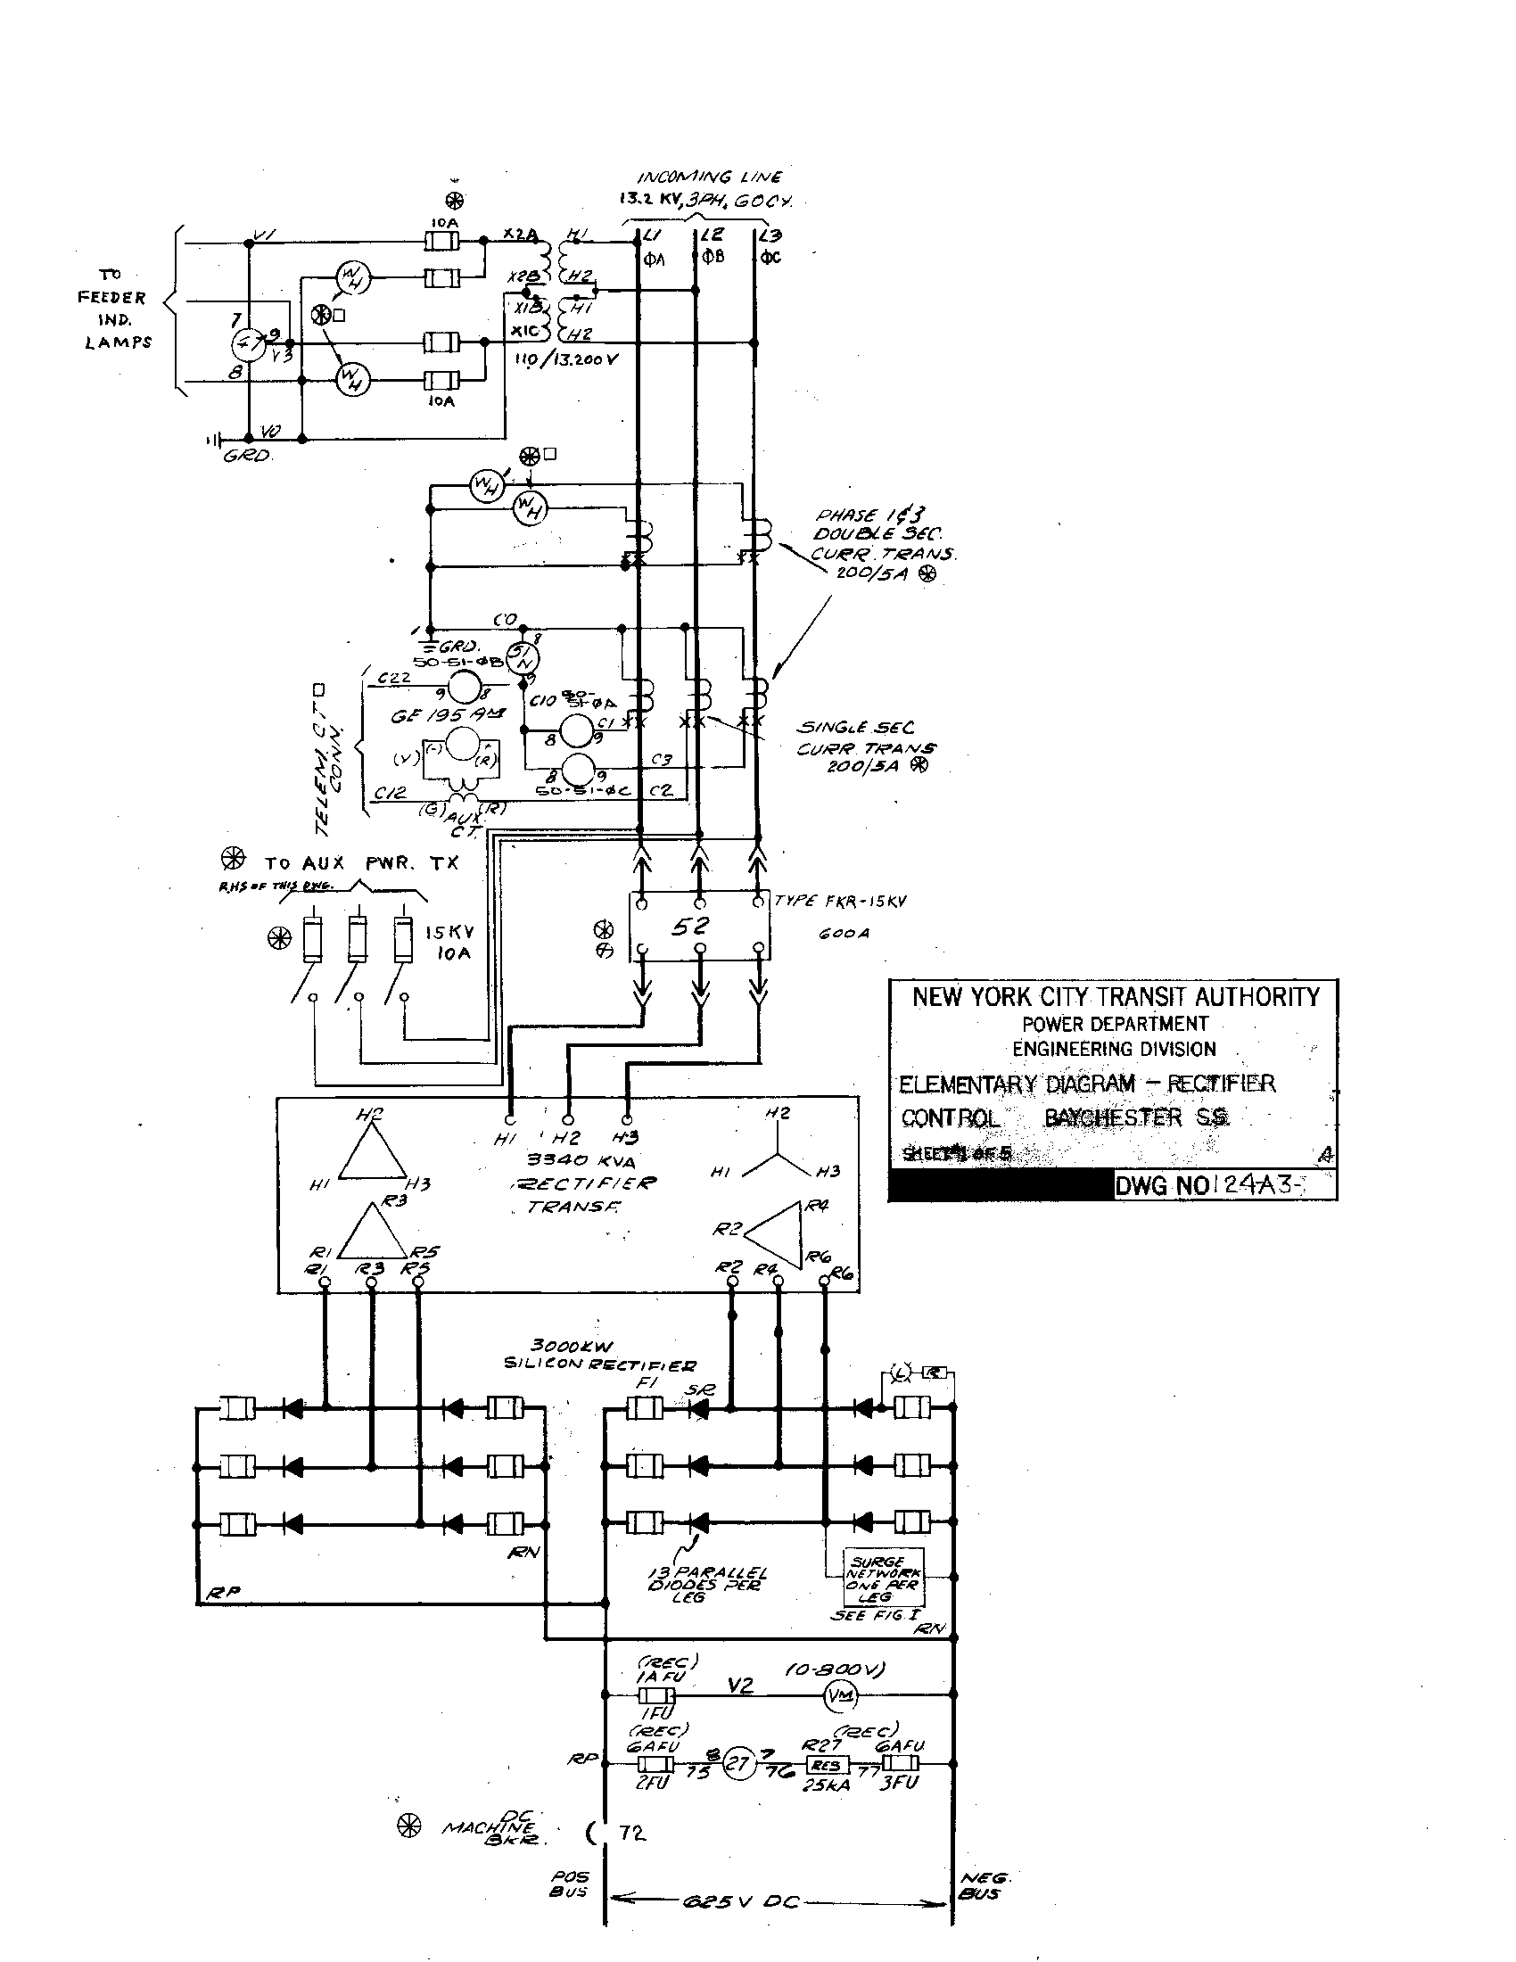

AC Train Worst-Case Track Circuits

In general, a worst-case track circuit is a long track circuit close to a substation, with the receiver end closer to the substation. Track circuits with low receive-end impedance and low track current operating levels tend to be most sensitive to train emissions. For single rail track circuits, the worst-case is when the signal rail is adjacent to the third rail. When a train is operating in a worst-case track circuit, its emissions cause the greatest impact when the train is far from the receiver.

A worst-case track circuit is one which is more susceptible to emissions, compared to all others. The susceptibility of a given track circuit is determined by the combination of:

* The peak interfering current in the track circuit receiver, which is a function of the input impedance of the track circuit receiver

* The sensitivity of the track circuit receiver, that is the current level at which it will operate.

For the worst-case track circuits set up on the NYCT test tracks, train emissions usually have their greatest effect on the track circuit when the train is using full power at medium speed near the transmit or southern end of the track circuit.

NYCT has identified four types of track circuits in use at NYCT as worst-case for AC Trains. These track circuit characteristics are summarized in Figure 6-5a and Figure 6-5b, AC Train Conducted EMI Worst-Case Track Circuits. The paper NYCTA NTTT EMC Project CM-828, Conductive EMI Analysis, Track Circuit Parameters, November 19, 1992, provides track circuit data and the calculation method. Figure 6-6a shows the general configuration, and defines the circuit parameters of interest for a single rail track circuit and for a double rail track circuit.

Appendix A provides a method and data for computing the current which will be driven into a worst-case track circuit for a selected train configuration. It can be used with the information in Figure 6-5a and Figure 6-5b and the following subsections as reference information to design EMI filters and other car equipment characteristics. H-cond and other information are provided for reference only. H-cond and other parameters may vary in the field.

NYCT staff will set up each worst-case track circuit for use by the carbuilder in the AC train Conducted EMI Test. NYCT staff are responsible to confirm that the signal equipment is:

- In correct working order
- Has the correct response as identified on the relay nameplate
- Is fit to be used in the test.

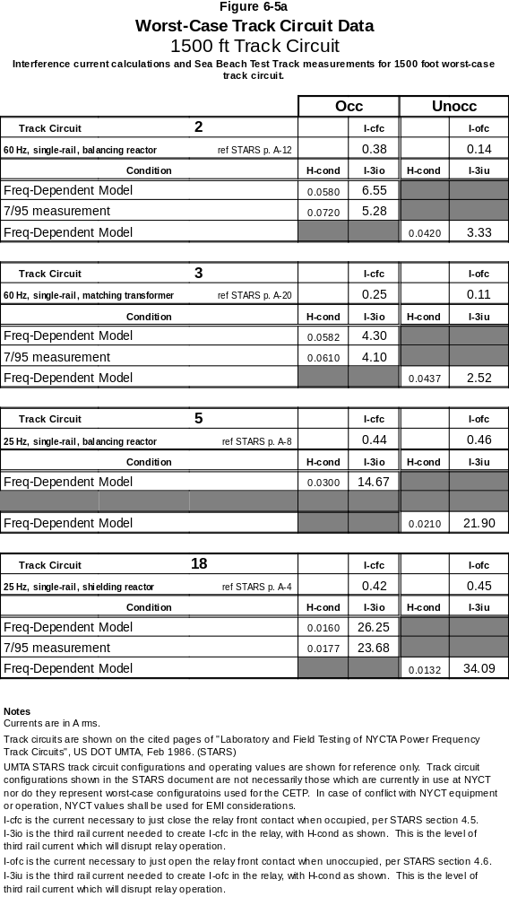

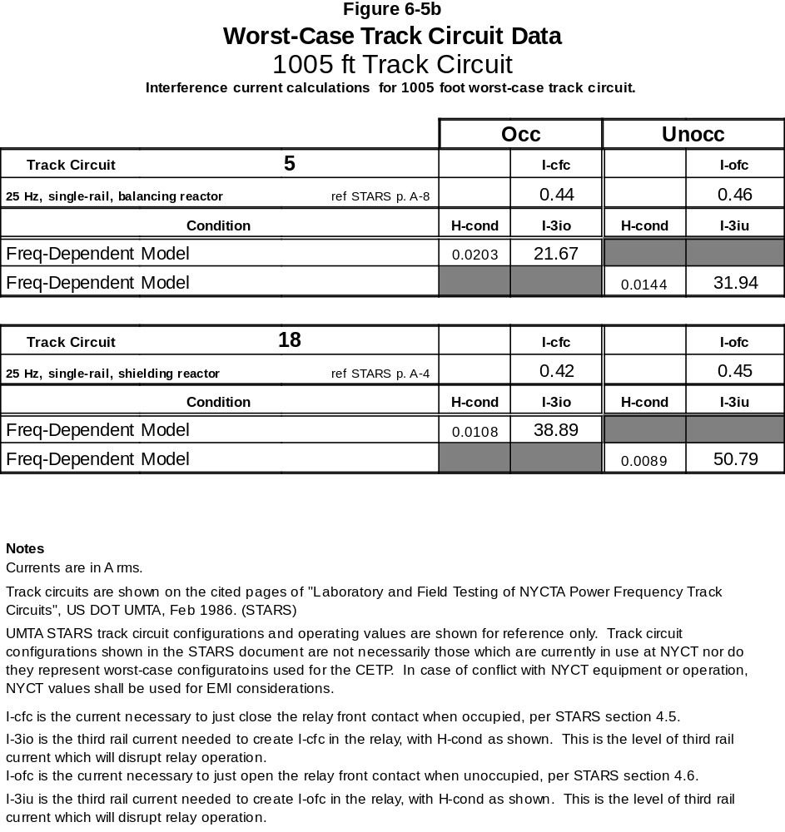

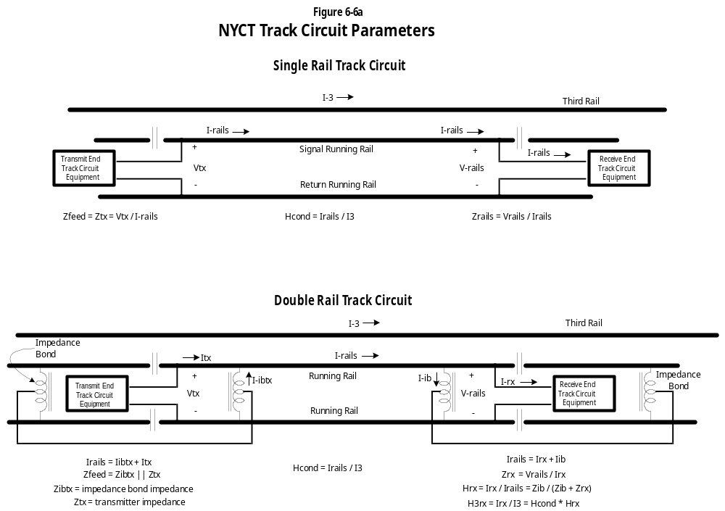

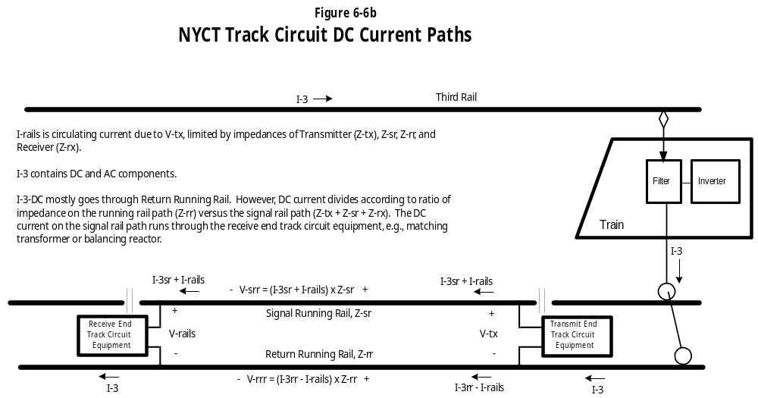

Information on track circuit configurations provided in this CETP supercedes earlier published UMTA information on the worst case configuration of NYCT track circuits. In case of conflict between published information and performance of NYCT track circuit equipment, the characteristics and configuration of the NYCT track circuit equipment shall govern EMI acceptance.

When an AC Train operates in a worst-case track circuit, a DC current as high as 90 A can flow in the I-rails circuit and in the ICR track circuit receiver equipment, such as the matching transformer or balancing reactor. Figure 6-6b shows the simplified circuit path for the DC current. The CETP test equipment is AC coupled to reduce the impact of the ICR DC current.

CETP Track Circuits

Based on earlier test results, NYCT has identified Track Circuit 3 as the in-service worst-case for 60 Hz and Track Circuit 5 as the in-service worst-case for 25 Hz. Unless the carbuilder is directed to the contrary by NYCT, the AC Train will be Conducted EMI-qualified for service if it passes the tests specified in this CETP for those two track circuits. Testing on other track circuits may be required by NYCT if specific results indicate problems with Track Circuit 3 or Track Circuit 5, or if for example NYCT determines that a test of a double-rail track circuit is required.

In 2004, when a major procurement of B Division AC Trains is planned to be delivered, NYCT plans that the only remaining 25 Hz track circuits on the NYCT B Division will be on the Broadway BMT between Whitehall Street and Lexington Avenue. When the next major procurement of A Division AC Trains is planned to be delivered, after 2004, NYCT plans that the only A Division 25 Hz track circuits left will be on the Lexington Avenue Line and on the Broadway IRT.

In 2004, NYCT plans that the worst-case NYCT 25 Hz track circuit will be 1,005 ft long. Until 2004, the worst-case NYCT 25 Hz track circuit will be 1,500 ft long. Accordingly, Figure 6-5a provides relevant parameters for the pre-2004 25 Hz track circuits. Figure 6-5b provides relevant parameters for the 25 Hz track circuits for 2004 and after.

The worst-case NYCT 60 Hz track circuit is 1,500 ft long. See Table 6-1 below.

Table 6-1

NYCT Worst Case Track Circuit Length
Frequency | Pre-2004 | 2004 and after
25 Hz | 1,500 ft | 1,005 ft
60 Hz | 1,500 ft | 1,500 ft

The representations concerning CETP worst-case track circuit lengths reflect current plans for signal modernization. The carbuilder shall consult relevant sections of the car procurement contract for guidance as to which worst-case track circuit shall apply for a particular procurement.

In the future (2010 – 2020), progress in the signal modernization program may result in further revision to the CETP with respect to worst-case 25 Hz track circuits, as these track circuits are gradually replaced.

The following subsections provide detailed technical information for each worst-case track circuit.

Track Circuit 3

Track Circuit 3 is a 60 Hz, single-rail track circuit using the GRS B2V relay. Its track coupling network is a matching transformer and 1.87 ohm resistor. The matching transformer provides a voltage stepup of 5:1 from the SEC side to the PRI side. Its resistor value is a worst-case configuration. The local coil of the track relay should be energized at 110 vac.

Track Circuit 3 is the most restrictive 60 Hz track circuit. Therefore, it requires the greatest attention.

Figure 6-7 shows the general connection for Track Circuit 3. Figure 6-8 shows the suggested connection of the Track Circuit 3 equipment to the CETP equipment, at the nodes labeled “TEST POINT”. The carbuilder can propose a connection on the B2V relay coil, if the carbuilder can demonstrate that the test setup has adequate dynamic range to reproduce actual signals.

Figure 6-9 shows the graphs for magnitude and phase of calculated H-cond versus frequency as well as H-cond measured at the Sea Beach test track.. Figure 6-10 shows the H-cond measured at the Sea Beach test track.

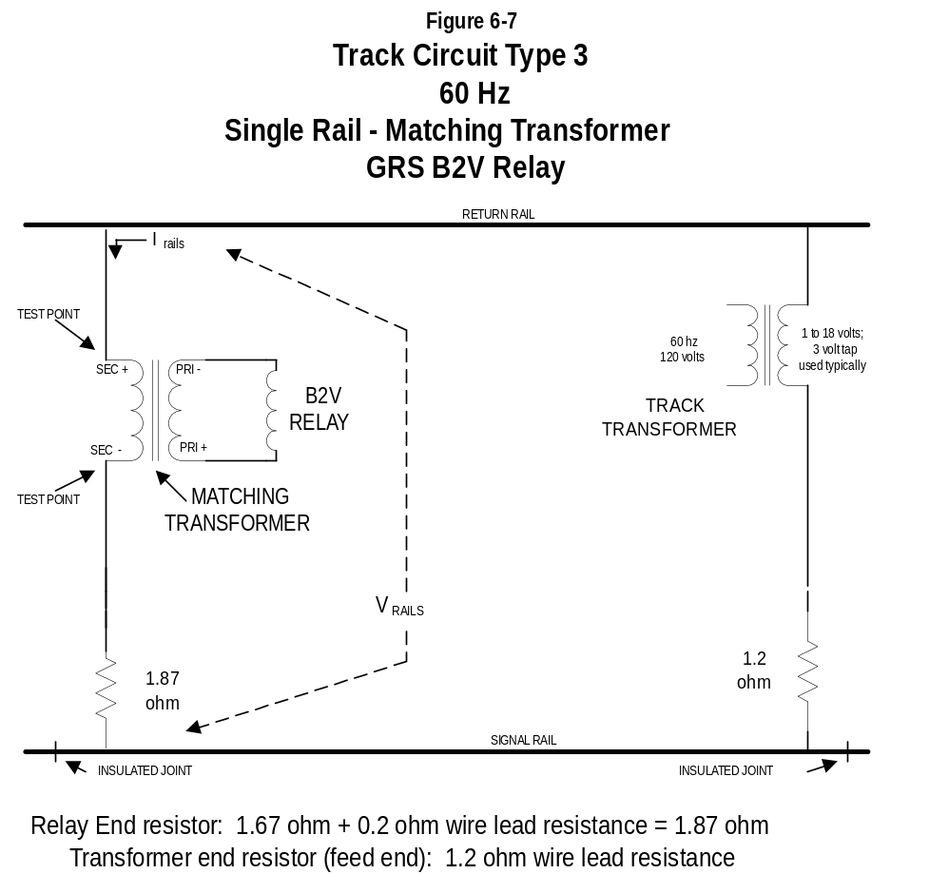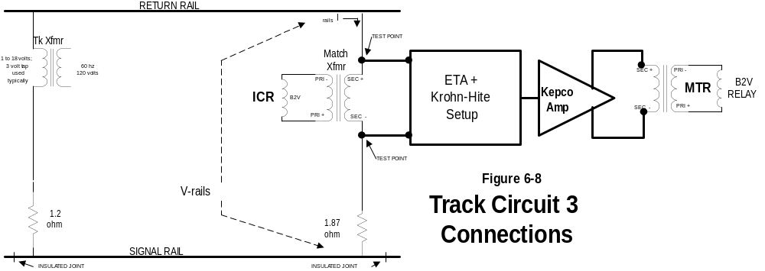

Figure 6-9 Track Circuit 3 Calculated H-Cond
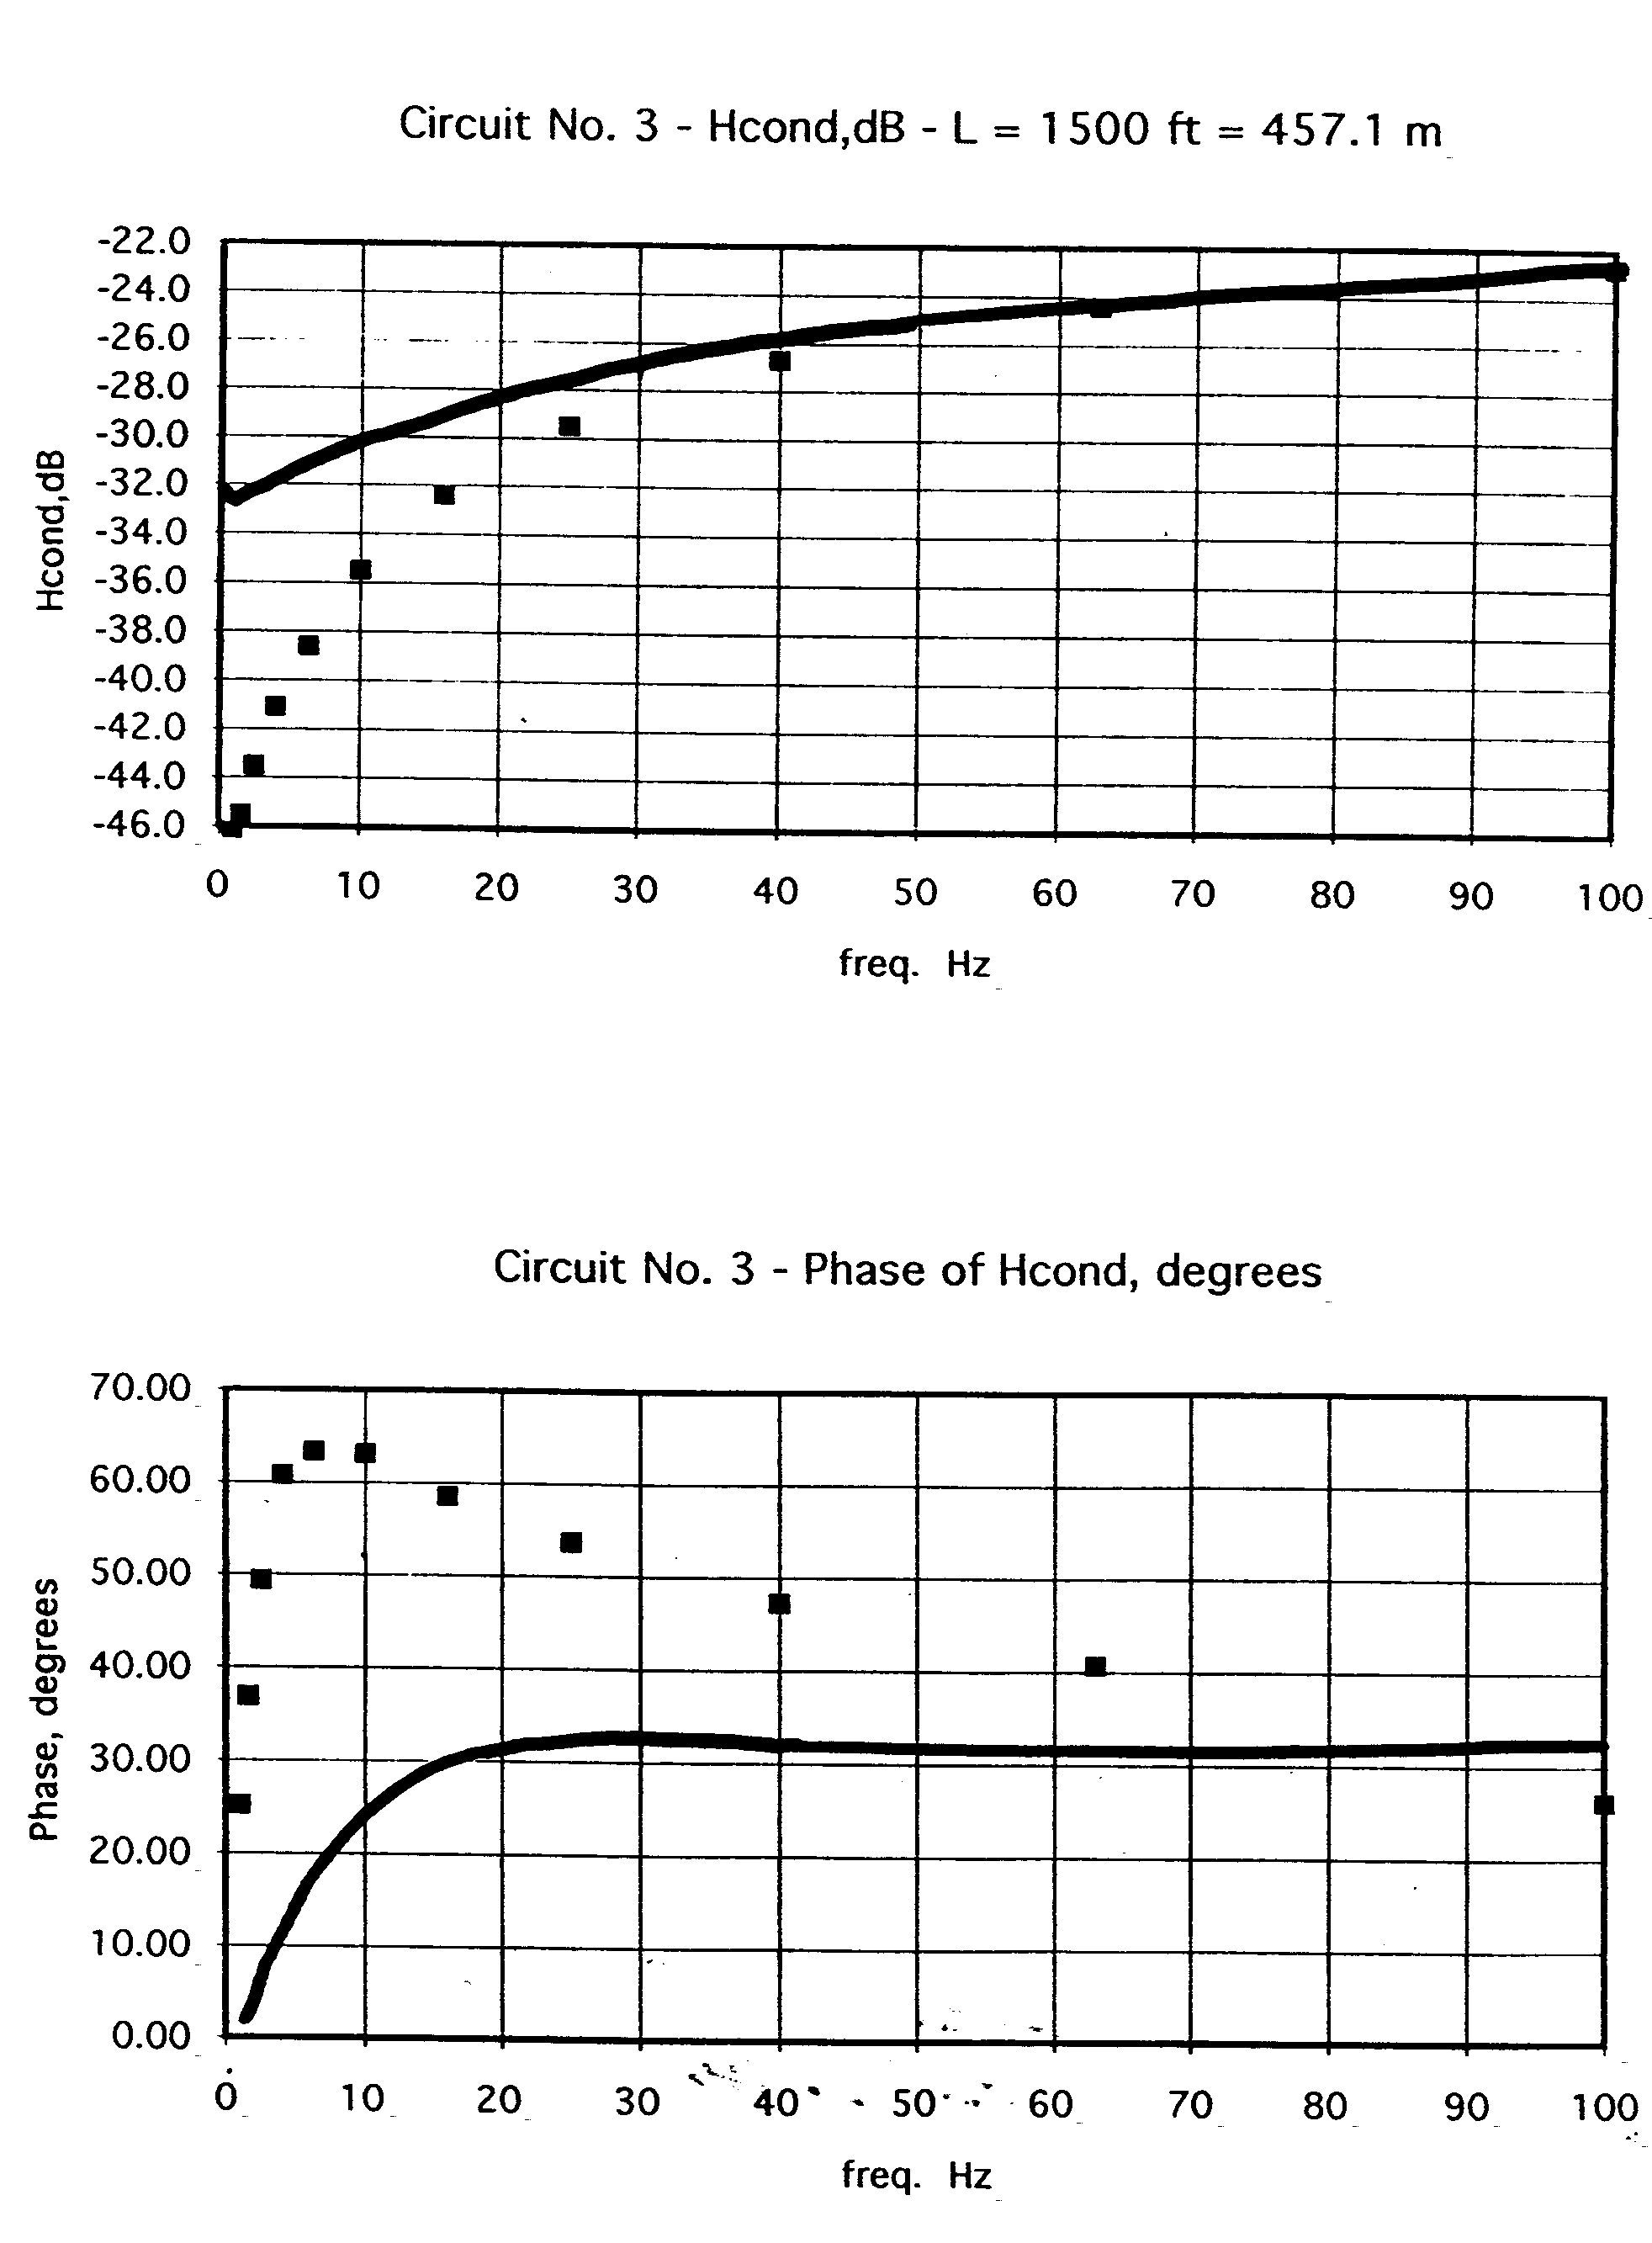

Figure 6-10 Track Circuit 3 H-Cond Measured at Sea Beach
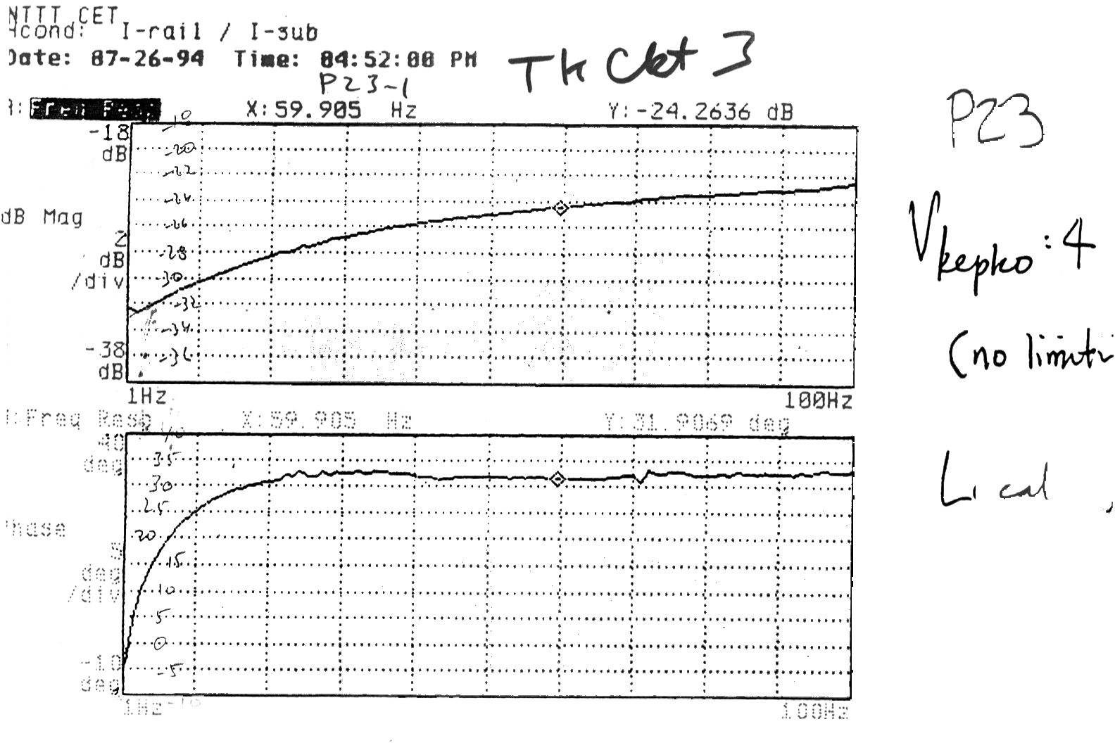

Track Circuit 5

Track Circuit Number 5 is a 25 Hz, single-rail track circuit using the GRS Model M2FA relay. Its track coupling network is a balancing reactor and resistor. Track Circuit Number 5 requires a non-worst-case resistor value of 1.87 ohm in the receiver side to protect it against current overload when installed near a substation. The local coil of the track relay should be energized at 63 vac.

Track Circuit Number 5 is the most restrictive case for 25 Hz.

Figure 6-11 shows the general connection for Track Circuit 5. Figure 6-12 shows the suggested connection of the Track Circuit 5 equipment to the CETP equipment, at the nodes labeled “TEST POINT”. The carbuilder can propose a connection at other points, if the carbuilder can demonstrate that the test setup has adequate dynamic range to reproduce actual signals.

Figure 6-13 shows a graph for the magnitude of the calculated H-cond versus frequency. Figure 6-14 shows a graph for the phase of the calculated H-cond versus frequency.

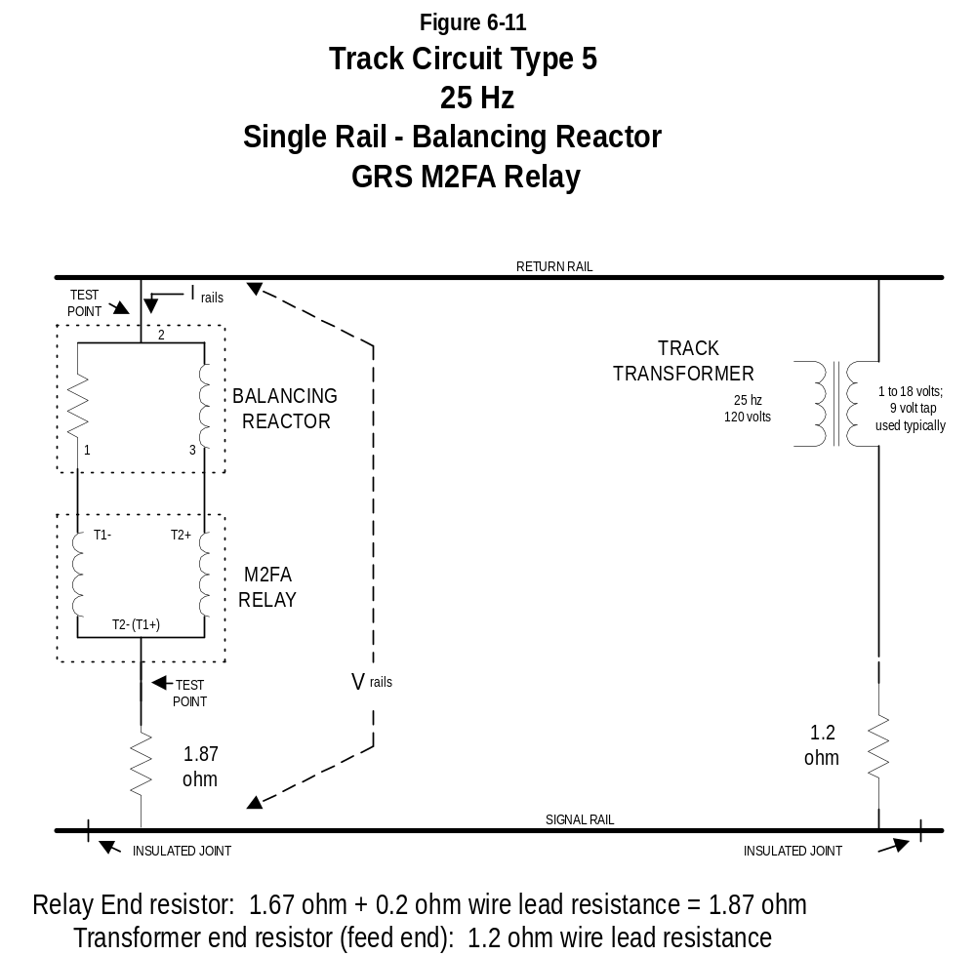

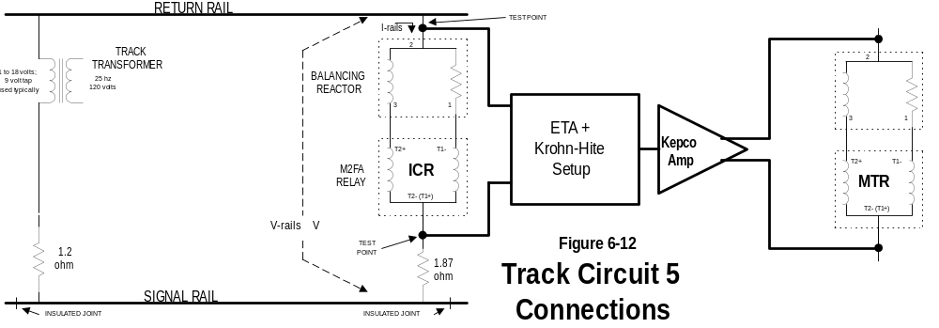

Figure 6-13 Track Circuit 5 Calculated H-Cond Magnitude
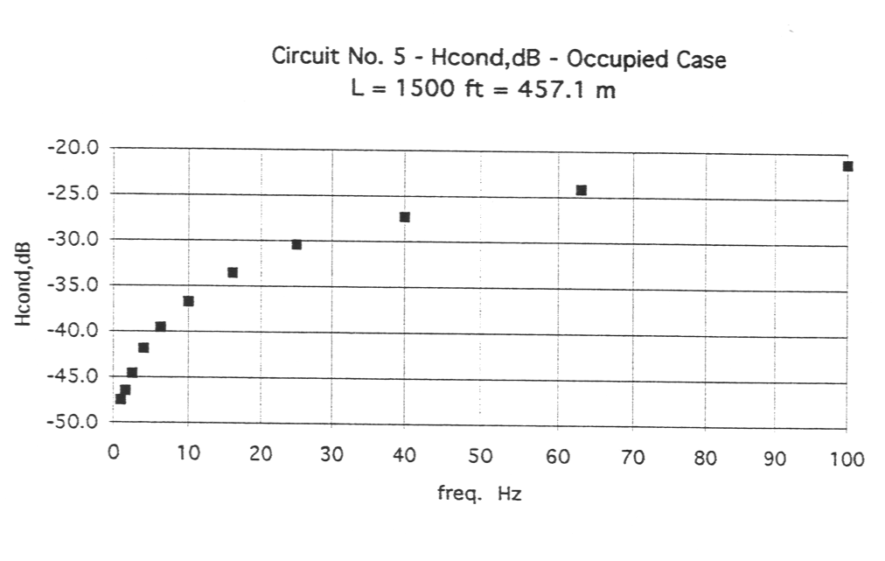

Figure 6-14 Track Circuit 5 Calculated H-Cond Phase
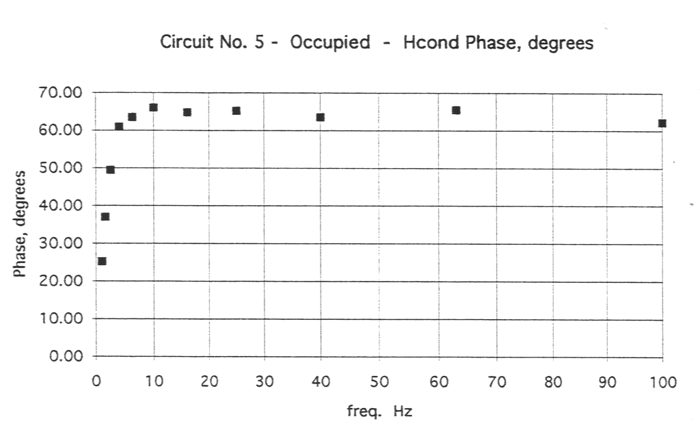

Track Circuit 2

Track Circuit 2 is a 60 Hz, single-rail track circuit using the GRS B2V relay. Its track coupling network is a balancing reactor and resistor. Track Circuit 2 requires a non-worst-case resistor value of 1.87 ohm in the receiver side to protect it against current overload when installed near a substation. The local coil of the track relay should be energized at 110 vac.

Track Circuit 2 is used in the CETP in the configuration shown below.

Figure 6-15 shows the general connection for Track Circuit 2. Figure 6-16 shows graphs for magnitude and phase of calculated H-cond versus frequency. Figure 6-17 shows the H-cond measured at the Sea Beach test track.

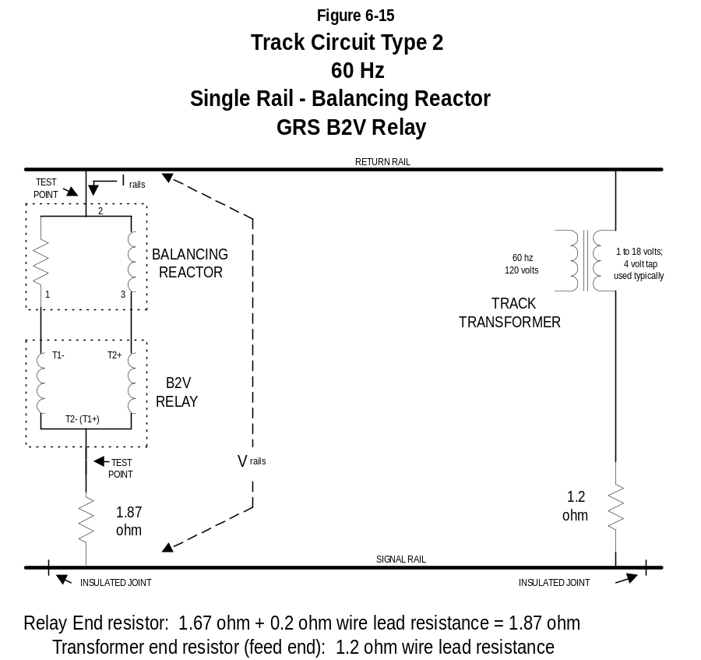

The suggested connection for the Track Circuit 2 equipment to the CETP equipment are noted as “TEST POINT” in Figure 6-15. The carbuilder can propose a connection at other points, if the carbuilder can demonstrate that the test setup has adequate dynamic range to reproduce actual signals.

Figure 6-16 Track Circuit 2 Calculated H-Cond
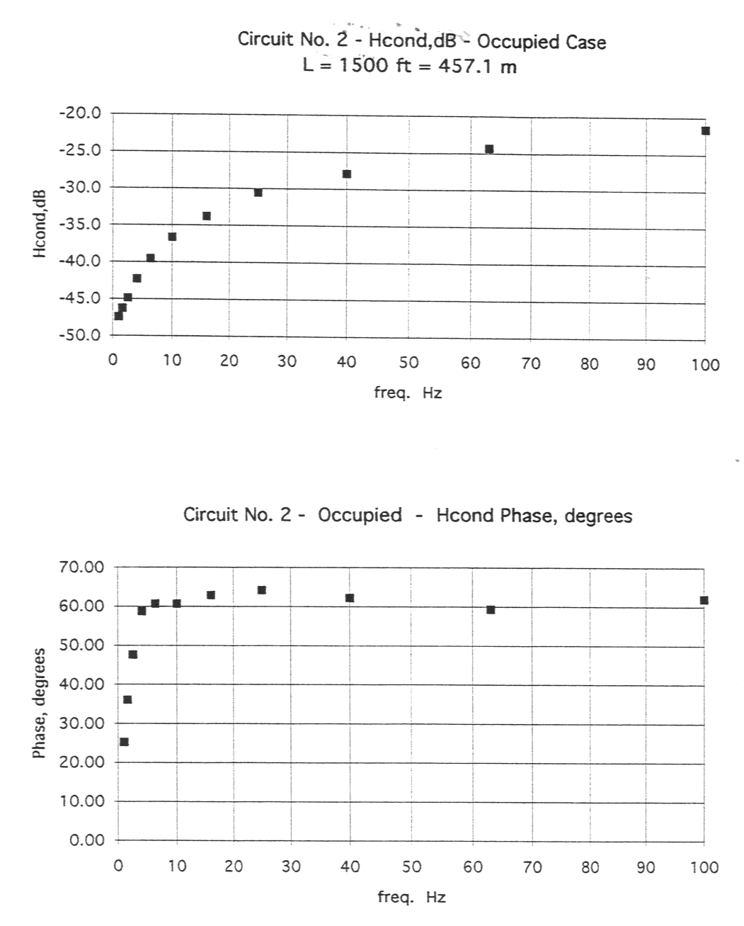

Figure 6-17 Track Circuit 2 Measured H-Cond

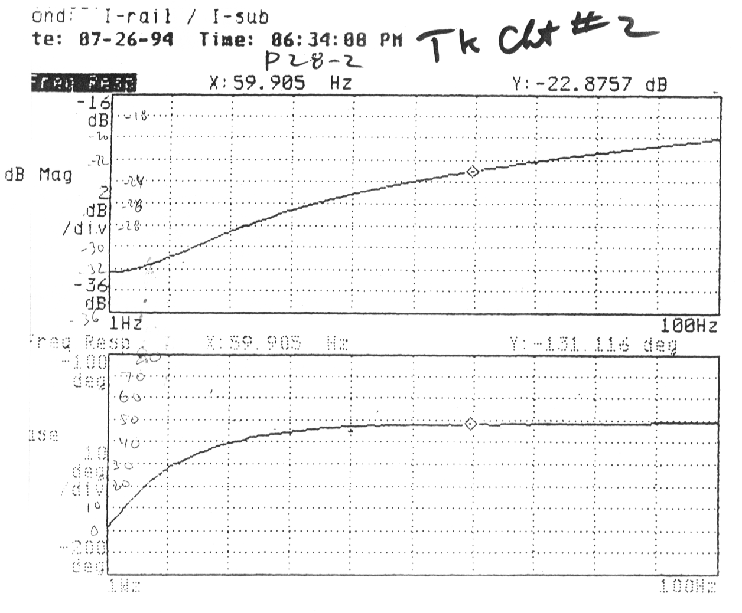

Track Circuit 18

Track Circuit 18 is a 25 Hz, single-rail track circuit using the US&S PTV-42 relay. Its track coupling network is a shielding reactor with 4.37 ohm and 1.67 ohm resistors. The local coil of the track relay should be energized at 63 vac.

Figure 6-18 shows the general connection for Track Circuit 18. Figure 6-19 shows graphs for magnitude and phase of calculated H-cond versus frequency. Figure 6-20 shows the actual measured H-cond data from previous Sea Beach tests.

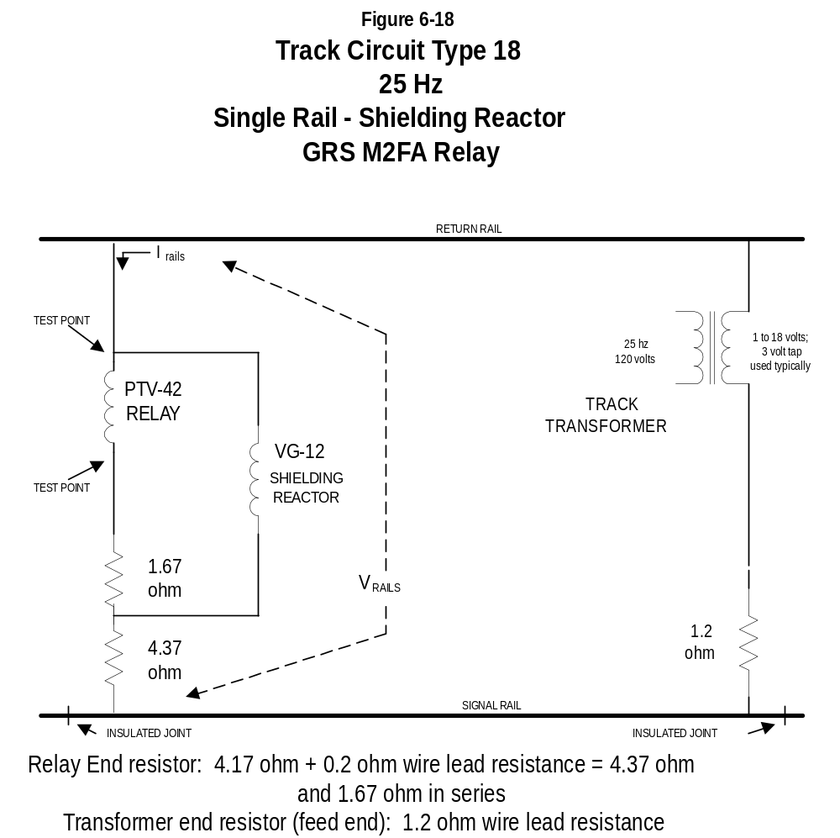

The suggested connection for the Track Circuit 18 equipment to the CETP equipment are noted as “TEST POINT” in Figure 6-18.

Figure 6-19 Track Circuit 18 Calculated H-Cond

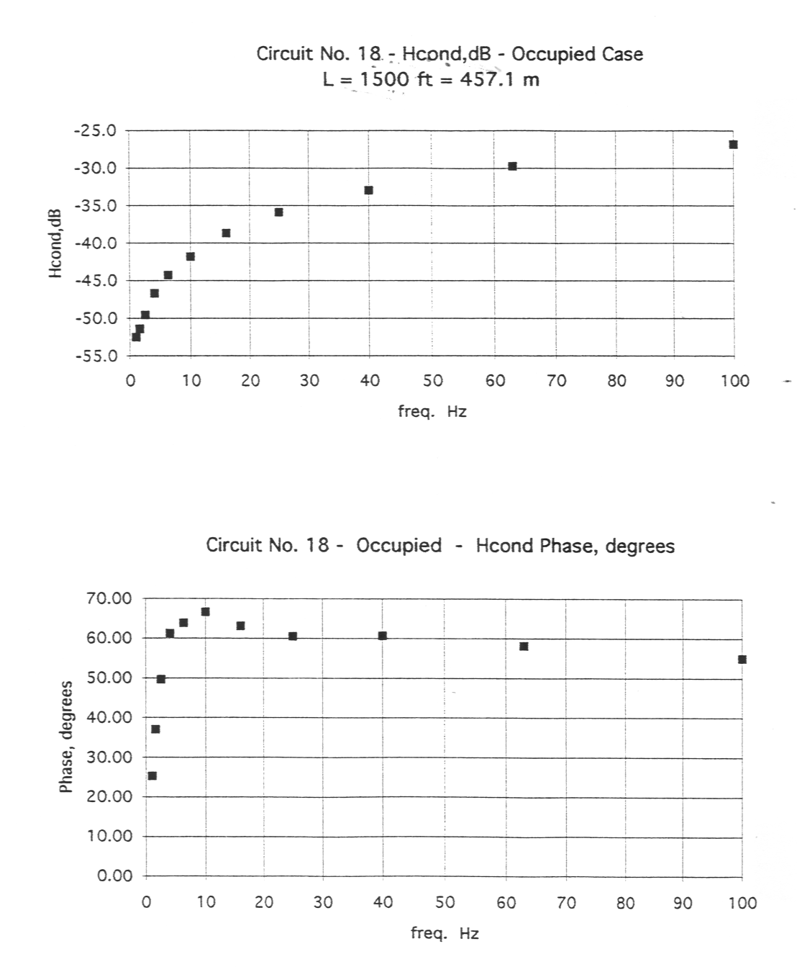

Figure 6-20 Track Circuit 18 H-Cond Measured At Sea Beach

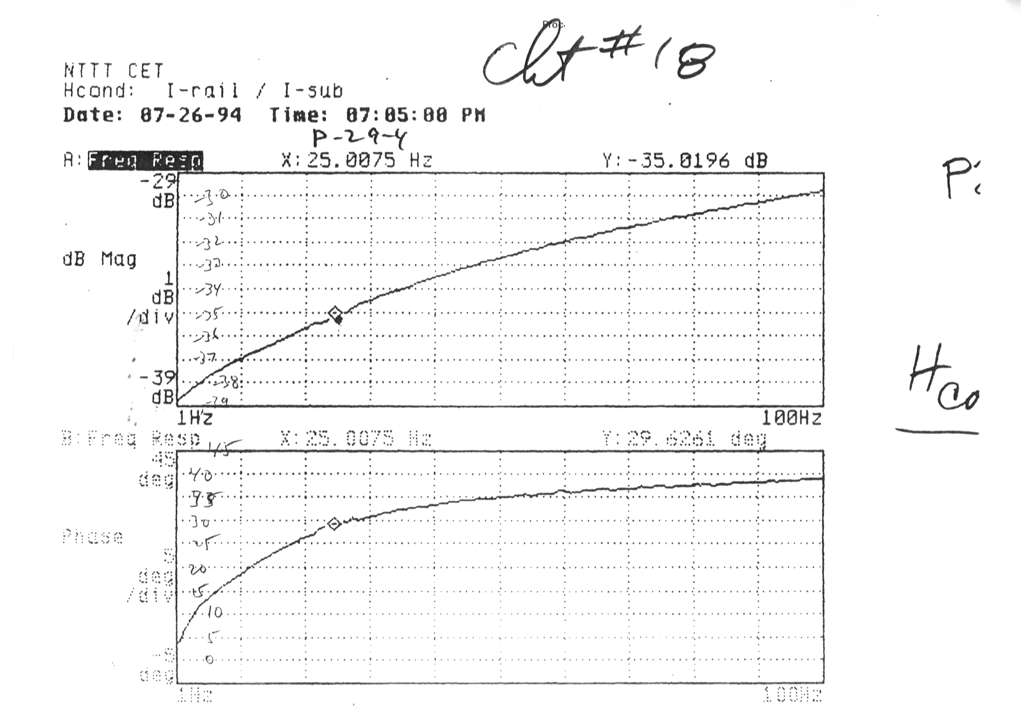

Acronyms

This CETP uses the following acronyms:

AW0 Train empty weight

AW3 Train crush loaded weight

BIE Brakes In Emergency

CBTC Communications-Based Train Control

CETP Conducted EMI Test Procedure

CET Conducted EMI Test

DAT Digital Audio Tape Recorder

EMC Electromagnetic Compatibility

EMI Electromagnetic Interference

ETA EMI Test Adapter

FSB Full Service Brake

HVAC Heating, Ventilating, and Air Conditioning

ICR In-Circuit Relay

IJ Insulated Joint

LEM Liasons Electroniques Mechaniques

LVPS Low Voltage Power Supply

MTA Metropolitan Transportation Authority

MTR Margin Test Relay

NTTT New Technology Test Train

NYCT New York City Transit

PWM Pulse Width Modulation

Appendix A

Computation of I-rcv / I-3, I-rcv / I-train
COMPUTATION OF Ircv/I3, Ircv/Itrain,sc AND THIRD-RAIL RUNNING-RAIL LOOP IMPEDANCES IN NYCTA POWER FREQUENCY TRACK CIRCUITS

F. Ross Holmstrom
UMass•Lowell
Dept. of Electrical Engineering
19 April 1993 - Updated 12 April 2001

1. INTRODUCTION
The accompanying spreadsheets give calculated data for overall track circuit harmonic current transfer function Hoverall , for selected NYCTA track circuits. This transfer function is the ratio of harmonic current into the receive end of the track circuit to the harmonic current that can be delivered at the end of a train into a short circuit. Hoverall is a function of frequency-dependent rail parameters, and also of train source impedance, track circuit length and receive-end impedance, and distance beyond track circuit receive end to substation. These computations were performed for the occupied case, in which the axles of the train short the running rails at a distance d from the receive end.
In power frequency track circuits in the occupied case, running-rail to running-rail impedance at any point in the track circuit is determined by the impedance of the shorted loop of track, since this impedance is much less than the rail-to-rail ballast resistance in track circuits of virtually any reasonable length. In this situation ballast conductance can be neglected. When ballast conductance between the running rails is set to zero, the circuit becomes a lumped circuit, as opposed to a distributed one. The reduction in the complexity of the problem arising from neglect of ballast conductance is so great that it pays to re-do the analysis from scratch rather than try to adapt the full distributed-circuit treatment of this problem in Ref. 1, to the simplified case.
The zero ballast conductance lumped-circuit approximation has been used in the computation of current transfer functions and circuit impedances in three geometries of power frequency track circuits under occupied conditions, as shown in Figure 1. The geometries are: (a) Signal rail adjacent third rail; (b) DC return rail adjacent third rail; and, (c) Balanced DC return path using a center-tapped impedance bond.
2. CIRCUIT PARAMETERS AND IMPEDANCES
The salient parameters of the circuit are given below:
r1 = r2 = r3 = 5 cm Effective radius of running rails and third rail
d12 = 150 cm running rail spacing for standard 4’-81/2” gage
d13 = 217 cm NYCTA third rail to farthest running rail center-to-center distance
d23 = 67.3 cm NYCTA third rail to nearest running rail center-to-center distance
μo = 4π x 10-7 H/meter = magnetic permeability of free space
R1,int = resistance of a single running rail per meter of length (see spreadsheets for values)
L1,int = component of inductance of a single running rail per meter length, due to magnetic fields inside the rail
X1,int = jωL1,int (see spreadsheets for values)
Z1,int = R1,int + jX1,int
(μo/2π)ln(d23/r3) = (μo/2π)ln(d23/r2) = 5.20 x 10-7 H/meter = magnetic flux per meter of track passing between third rail & nearest running rail per ampere in rail 2 or 3
(μo/2π)ln(d12/r1) = (μo/2π)ln(d12/r2 = 6.80 x 10-7 H/meter = magnetic flux per meter of track passing between the running rails per ampere in either running rail
M3rr = (μo/2π)ln(d13/d23) = 2.34 x 10-7 H/meter = magnetic flux per meter of track passing between running rails per amper in third rail
(μo/2π)ln(d13/d12 ) = 7.39 x 10-8 H/meter = magnetic flux per meter of track passing between third and nearest running rail per ampere in farthest rail
Rtk = 2R1,int = track loop resistance per meter of track length (see spreadsheets for values)
Xtk = 2πf •2•[L1,int + (μo/2π)ln(d12/r1)] = track loop reactance per meter of track length (see spreadsheets for values)
Zrcv = Rrcv + j Xrcv = track circuit receiving-end impedance (track relay plus other components)
Lbond = 1.337 mH = end-to-end impedance bond inductance
Zbond = Rbond + jXbond  jωLbond since Rbond << ωLbond at power frequencies

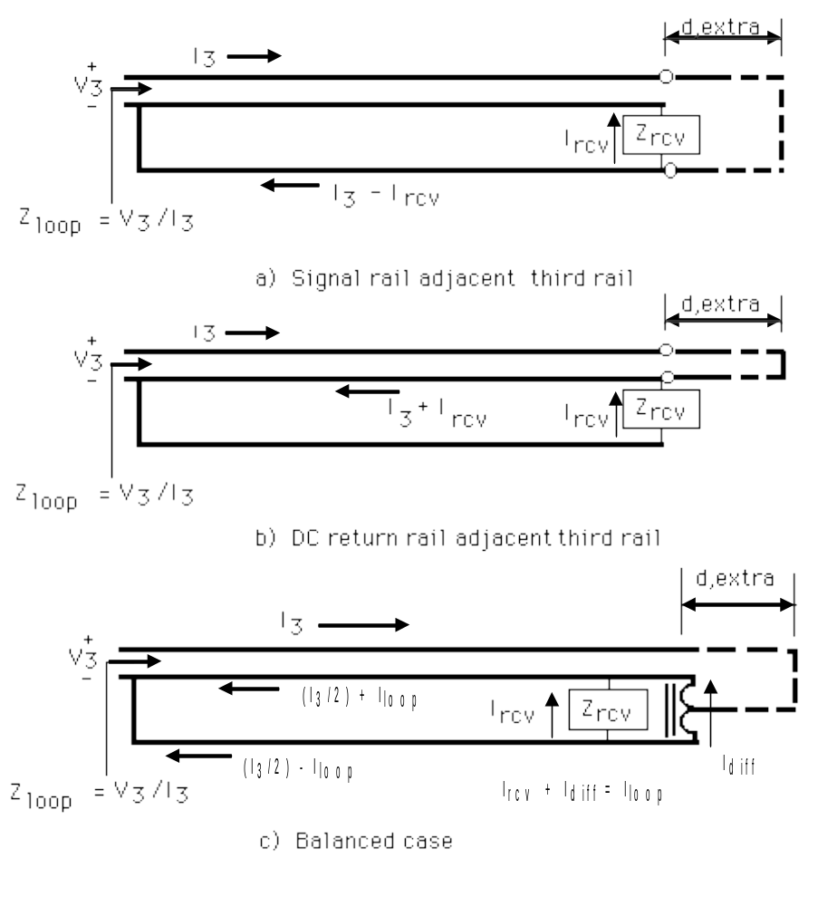 Figure 1. Three geometries of occupied track circuits.

Zloop = Rloop + jXloop = third-rail running rail loop impedance of from train to receiver
d = track circuit length from receiver end to nearest of axle of train in occupied case
dextra = length of third rail running rail loop from receiver end of track circuit to substation
Zextra = Rextra + jωLextra = added series impedance of third rail running rail loop from receiver end of track circuit to substation, where Lextra is nominally taken as 1uH/meter, and Rextra is nominally taken as zero, since Rextra << ωLextra at power frequencies.
Itrain,sc = Itsc = Norton equivalent short-circuit harmonic current injected into the third rail by the entire train, equal to some fraction times the sum of short-circuit currents from all inverters in the train
Ztrain = source impedance of the train equal to input impedance of ladder circuit comprised of line filters in shunt and inter-car inductances in series.

3. CIRCUIT EQUATIONS
3.1 Signal Rail Adjacent to Third Rail
Applying Kirchoff’s voltage law (KVL) around the lower loop in Fig. 1(a) including the effects of voltages induced by magnetic flux, with polarity of induced voltages determined according to the right-hand rule, yields the equation
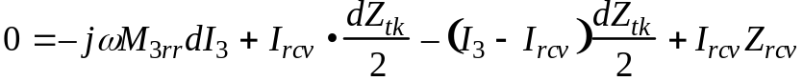 (1)
This equation is easily rewritten in the form that gives Hcond, the ratio of track circuit receive-end harmonic current to third rail current:
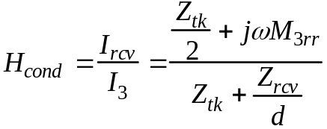 (2)
Applying KVL around the top loop of Fig. 1(a) yields the equation
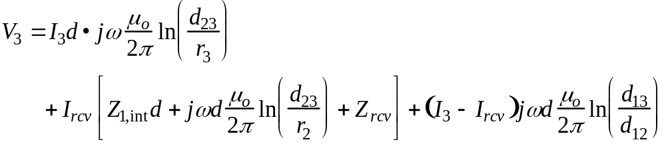 (3)

Eqn. 2 can be used to eliminate Ircv from Eqn. 3, which can then be used to find Zloop:
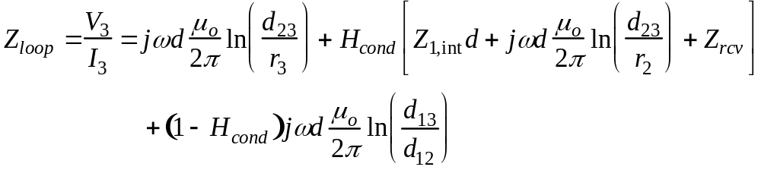 (4)
The loop impedance above is what would be measured if the receiving end of the track circuit were very near a substation. When that is not the case, an overall Zloop can be estimated by adding an extra nominal inductance of 1 μH for every meter from the receiving end of the track circuit to to substation:
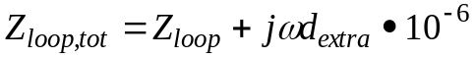 (5)
The train’s Norton equivalent short circuit harmonic current Itrain,sc divides between the train’s own source impedance Ztrain and the third rail running rail loop according to the relation
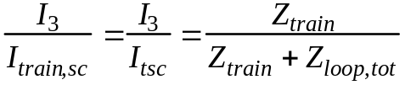 (6)
which can be combined with Hcond as given in Eqn. 2 to yield the overall conducted interference transfer function
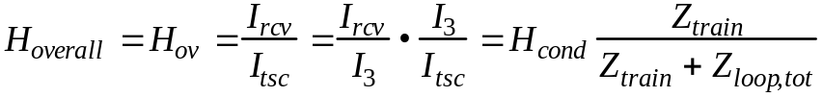 (7)
3.2 DC Return Rail Adjacent to the Third Rail
Applying KVL around the lower loop in Fig. 1(b) yields a relation for Hcond for this case, analogous to Eqn. (2) for the previous case:
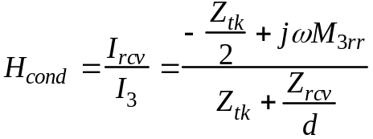 (8)
Applying KVL around the upper loop in Fig. 1(b) gives the relation
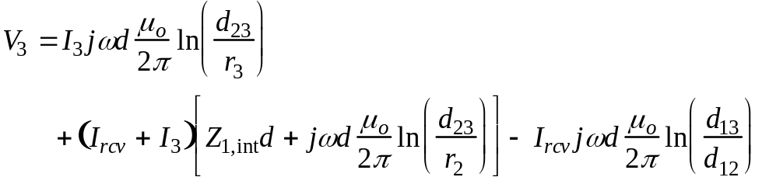 (9)
When Eqn. 8 is used to eliminate Ircv from Eqn. 9, the resulting equation can be written as
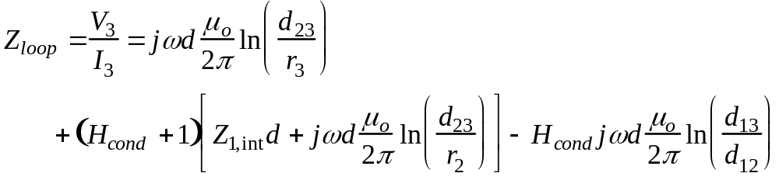 (10)
Eqn’s 5 - 7 are used as is to find Hoverall for this case.

3.3 Balanced Track Circuit with Center Tapped Impedance Bond for DC Return Current
The impedance bond in Fig. 1(c) can be modeled as an ideal balanced autotransformer, implying that it has the following properties: First, the self inductance of each end, measured from end to center tap with the other end open-circuited, is equal to that of the other. Second, the mutual inductance of each end with respect to the other is equal to its own self inductance; and third, winding resistance can be neglected compared to the reactances involved. The latter simplification is justified on the basis of the known resistance to reactance ratio of the bonds involved in this computation.
The currents through the bond can be separated into common-mode and differential-mode components, with
Icomm = I3 (11)
and
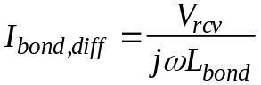 (12)
The exactness of Eqn. 12 depends upon the self-inductances of the bond halves equaling the mutual inductances between the opposite ends.
The currents in the running rails then can be separated into a common-mode portion equal to I3 flowing to the left, dividing equally between the running rails, and a loop current
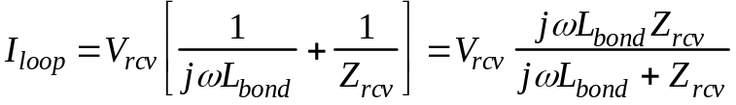 (13)
Accepting these simplifying assumptions, application of KVL to the lower loop in Fig. 1(c) yields an equation that can be put in the form
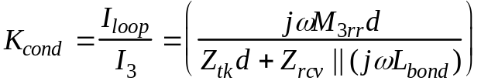 (14)
The ratio of Ircv to Iloop is given by the relation
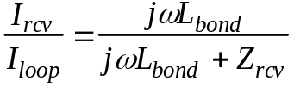 (15)
which may be used to find the relation for Hcond for this geometry:
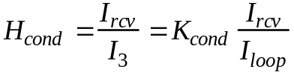 (16)
KVL around the top loop of Fig. 1(c) yields the relation
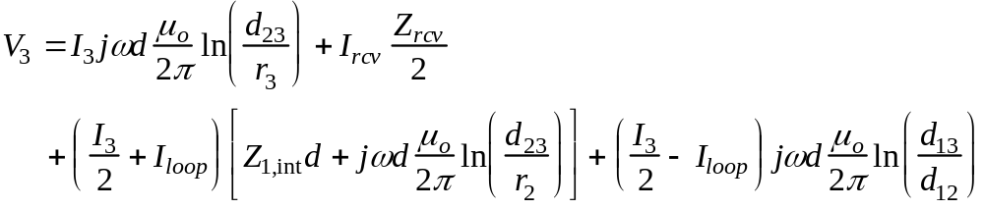 (17)
When Eqn’s 14 and 16 are used to eliminate Iloop and Ircv from this equation, the result can be written as
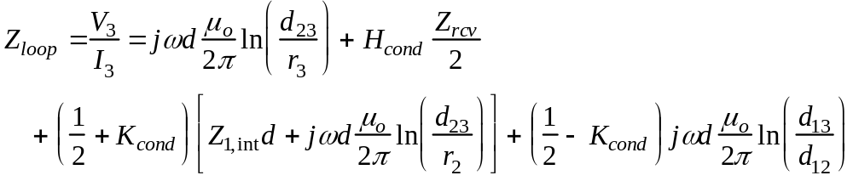 (18)
Once again, Eqn’s 5 - 7 apply, just as in the first case considered.

4. SPREADSHEET COMPUTATION
4.1 Description
Spreadsheets were written separately for each of the geometries pictured in Figure 1. Each output spreadsheet is four pages long. Spreadsheet pages 1 and 2 summarize input data and calculate real and imaginary parts of Hcond. In the balanced case, real and imaginary parts of Kcond are calculated as well.
On spreadsheet page 1, Nr, Ni, Dr, and Di are the real and imaginary parts of numerator and denominator of expressions for Hcond, given by Equations 2, 8 and 16 for the three geometries. Terms C and D appearing on page 1 of spreadsheets for the unbalanced cases are intermediate terms used in calculating Rloop and Xloop, tabulated on page 2. These columns are used to tabulate Kr and Ki in the balanced case.
Using values of Rloop, Xloop and Hcond tabulated on spreadsheet pg. 2, a single value of Ztrain and four values of dextra are then used to calculate Hoverall, the overall harmonic current transfer function. The single value of Ztrain for which results are given on pg. 2 is 0.5 mH. Hoverall is tabulated for further values of Ztrain on following pages.
4.2 Cases Considered
Calculations were made for 29 different track circuit configurations asked for by Steve Shooman of the NYCTA Signal Department. These included track circuits of type 2, 3, 5, 7, 15, and 18, with varying values of Rrcv and Xrcv; these type numbers have been assigned for purposes of the Advanced Technology Train program. Track circuit configurations types and receive-end impedances are tabulated here in the table on the next page.
Calculations were made for four values of Ztrain typical of GE-powered trains of various consist and four values typical of AEG-Westinghouse powered trains. For each combination of track circuit and Ztrain, track circuit lengths of 1200 ft (366 m), 1000 ft (305 m), and 800 ft (244 m) were used. Four values of dextra, the distance to substation were used: 0, 1000, 2000, and 4000 ft ( 0, 305, 610, and 1220 m).
4.3 Discussion of Results
Not surprisingly, the greater the value of dextra, Rrcv and Xrcv, the smaller Hoverall is. Because of the fact that the train is described as a Norton equivalent source, increasing Ztrain in magnitude has the effect of increasing Hoverall. If this seems counter-intuitive, it must be remembered that increasing Ztrain in magnitude will cause the actual value of Itrain,sc to decline in the first place.

Table 1. Track circuit configurations and receive-end impedances
Shooman’s
Line Track Ckt Type
Number & Frequency Geometry Rrcv Xrcv

1 2 (60 Hz) Sig. r. adj. 3rd r. 1.166 0.83
2 “ “ 1.766 “
3 “ “ 2.366 “
4 “ Ret. r. adj. 3rd r. 1.166 “
5 “ “ 1.766 “
6 “ “ 2.366 “
7 3 (60 Hz) Sig. r. adj. 3rd r. 1.0946 1.407
8 “ “ 2.7646 “
9 “ “ 5.2646 “
10 “ “ 6.0946 “
11 “ Ret. r. adj. 3rd r. 1.0946 “
12 “ “ 2.7646 “
13 “ “ 5.2646 “
14 “ “ 6.0946 “
15 5 (25 Hz) Sig. r. adj. 3rd r. 1.1276 0.3064
16 “ “ 1.7276 “
17 “ “ 2.3276 “
18 “ Ret. r. adj. 3rd r. 1.1276 “
19 “ “ 1.7276 “
20 “ “ 2.3276 “
21 7 (25 Hz) Balanced 0.0814 0.0387 (with bond)
22 15 (60 Hz) “ 0.9117 1.7877
23 “ “ 2.5817 “
24 “ “ 5.0817 “
25 “ “ 5.9117 “
26 18 (25 Hz) Sig. r. adj. 3rd r. 2.5533 0.8296
27 “ “ 2.7724 1.8814
28 “ Ret. r. adj. 3rd r. 2.5533 0.8296
29 “ “ 2.7724 1.8814

Values of Hcond are highest for the geometry in which the signal rail is adjacent to the third rail. This geometry does have the highest magnitude of Zloop, but the degree by which it exceeds Zloop for the geometry where the DC return rail is adjacent to the third rail is not as great as the difference in Hcond values for the two cases.
In all three cases, when Rrcv and Xrcv are set equal to zero, at 60 Hz and 366 meters (1200 ft) track circuit length, Rloop = 0.0176 Ω, and Xloop = 0.132 Ω, corresponding to a third-rail running-rail loop inductance of 0.96 μH/meter.
With Rrcv set equal to 1 MΩ at 60 Hz, corresponding loop inductances are 1.13 μH/meter with the DC return rail adjacent to the third rail, and 1.63 μH/meter with the signal rail adjacent to the third rail. The higher inductance of the case of signal rail adjacent third rail is due to the fact that the distance between conductors carrying current is greater in this case. The balanced case loop inductance maintains has the same value whether Zrcv is zero or infinity.

5. EXTENSION OF MODELING TO CALCULATE RATIO OF TRACK CIRCUIT RECEIVER CURRENT TO INVERTER CURRENTS OF MULTI-CAR TRAINS
The circuit simulation program SPICE has been used to calculate the conductive emission characteristics of multi-car trains. A train is modeled as a distributed ladder network with series inductances each equal to 1 μH/meter times car length in meters, and with shunt branches in the form of inverter filters fed with inverter link current sources.
The SPICE circuit model includes a short circuit at the front end of the train, and SPICE calculates the current components through this short circuit due to each inverter. Allowing all of the inverter link currents to be one unit in size and summing all of the components to short circuit current produces the ratio I_{train,sc}/I_{link}, where I_{link} here represents the the current level simultaneously being produced by each inverter in the train. Turning off all of the inverter current sources allows a SPICE calculation of the train’s source impedance Z_{train}.
Spreadsheets similar to those attached to this document have been modified to include calculation of
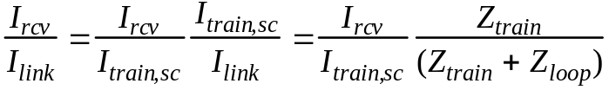 (19)
This resulting computational procedure allows analysis of the effects of all circuit parameters, including those of the train inverters, track circuitry, and rails, on the levels of conductive EMI reaching track circuit receivers.

REFERENCE
F. Ross Holmstrom, “Conductive Interference in Rapid Transit Signaling Systems -
Volume 1: Theory and Data”, Rept. No. UMTA-MA-0153-85-5; DOT-TSC-UMTA-85-21, November 1985.

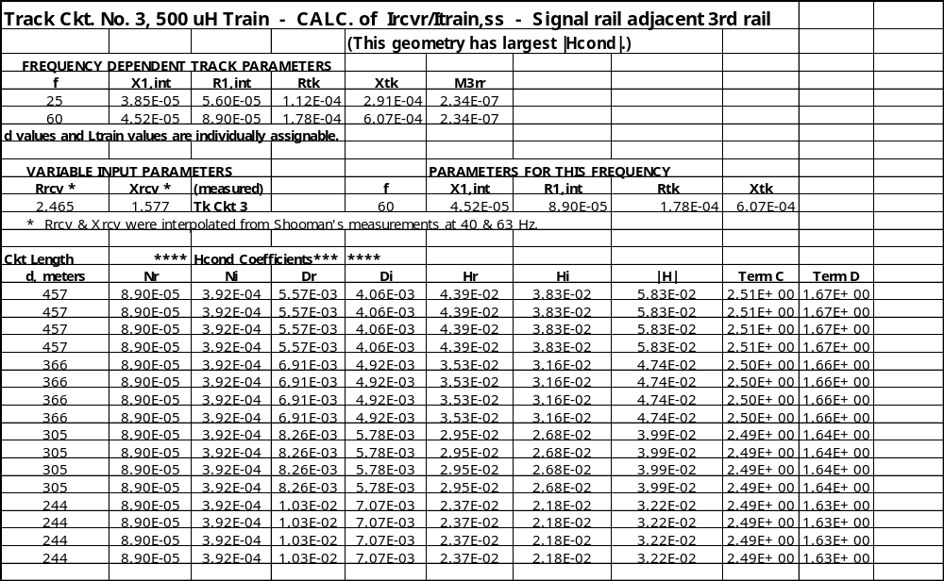
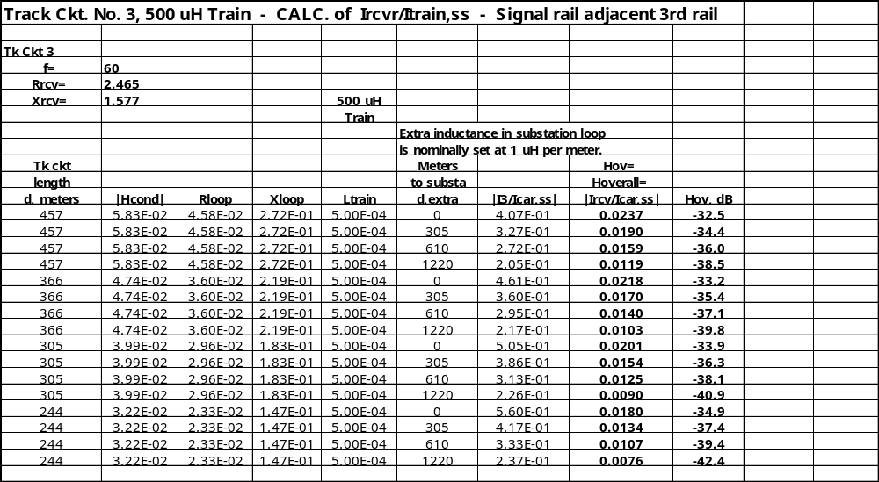

Appendix B

EMI Test Adapter Block Diagram and Schematic

